Contents

ROUTING SERVICES IN AZURE 3

LOAD BALANCER 4

LOAD BALANCER CONCEPT 5

COMPONENTS OF LOAD BALANCER 5

LOAD BALANCER SKUs 5

TYPES OF LOAD BALANCER 5

BASIC LOAD BALANCER (VMs in AVAILABILITY SET) 7

LOAD BALANCER NAT RULES 14

MUTIPLE BACKEND POOL AND FRONTEND IP ADDRESS OF LB 15

BASIC LOAD BALANCER (SCALE SET) 16

STANDARD LOAD BALANCER 22

AZURE APPLICATION GATEWAY 33

APPLICATION GATEWAY FEATURES 34

APPLICATION GATEWAY COMPONENTS 36

APPLICATION GATEWAY – PATH BASED ROUTING 37

SETTING UP APPLICATION GATEWAY – URL ROUTING 38

APPLICATION GATEWAY WITH WEBAPP (URL ROUTING) 42

APPLICATION GATEWAY – REWRITE 43

APPLICATION GATEWAY WITH APIM 45

USER DEFINED ROUTES 45

USECASE - SETTING UP USER DEFINED ROUTE 46

NETWORK WATCHER 55

AZURE BASTION SERVICE 55

SETTING UP BASTION SERVICE 56

EXPRESS ROUTE 61

AZURE FIREWALL 61

WHAT IS A FIREWALL 62

AZURE FIREWALL SERVICE 62

AZURE TRAFFIC MANAGER 70

TRAFFIC MANAGER ENPOINTS 71

AZURE TRAFFIC MANAGER ROUTING METHODS 71

PRIORITY ROUTING METHOD 72

PERFORMANCE ROUTING METHOD 74

GEOGRAPIC ROUTING METHOD 75

PERFORMANCE VERSUS GEOGRAPHICAL ROUTING 75

WEIGHTED ROUTING METHOD 76

SUBNET ROUTING METHOD 78

MULTIVALUED ROUTING METHOD 78

TRAFFIC MANAGER – NESTED ROUTING 78

AZURE FRONTDOOR 80

SETTING UP FRONTDOOR 82

DOMAIN NAME SYSTEM 85

DOMAIN REGISTRAR 87

ZONE FILE 88

ROUTING A DOMAIN TO A VM 89

AZURE PUBLIC DNS 89

AZURE DNS ZONE SERVICE 89

LOCAL DNS 92

AZURE PRIVATE DNS 92

SETUP THE VMs 92

CREATE PRIVATE DNS ZONE 92

LINK THE VNET WITH PRIVATE DNS ZONE 93

ACCESS THE RESOURCE 94

AZURE DNS – PEERED NETWORKS 96

## ROUTING SERVICES IN AZURE

* In Azure, the Routing service refers to Azure routing capabilities that manage and control network traffic within the Azure environment.

ROUTING SERVICES IN AZURE

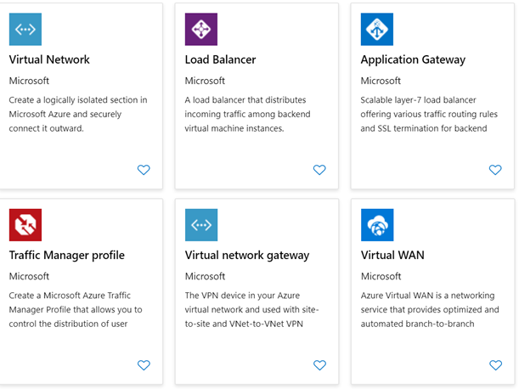

* AZURE VIRTUAL NETWORK (VNET):
  1. Azure Virtual Network is the foundation of the Routing service in Azure. It allows you to create isolated virtual networks where you can define subnets, IP address ranges, and network security groups. VNets serve as the logical boundaries for routing traffic within Azure.
* AZURE VIRTUAL NETWORK GATEWAY
  1. Azure Virtual Network Gateway is a routing service that provides secure and private connectivity between Azure virtual networks and on-premises networks. It enables Site-to-Site VPN or ExpressRoute connections, allowing you to extend your on-premises network to Azure.
* AZURE LOAD BALANCER
  1. Azure Load Balancer is a routing service that distributes incoming network traffic across multiple backend resources, such as virtual machines or virtual machine scale sets, to ensure high availability and scalability.
  2. It supports both internal and public-facing applications.
* AZURE TRAFFIC MANAGER
  1. Azure Traffic Manager is a DNS-based global load balancing and routing service.
  2. It allows us to distribute incoming network traffic across multiple endpoints in different Azure regions or across different deployment environments.
  3. It helps optimize application performance and availability.
* AZURE APPLICATION GATEWAY
  1. Azure Application Gateway is a web traffic load balancer and application delivery controller.
  2. It provides advanced routing and security features for HTTP/HTTPS traffic, such as URL-based routing, SSL termination, and web application firewall (WAF) protection.
* AZURE FIREWALL
  + Azure Firewall is a managed network security service that provides stateful packet filtering and network address translation (NAT).
  + It helps secure Azure virtual network by enforcing application and network-level policies, including routing rules.

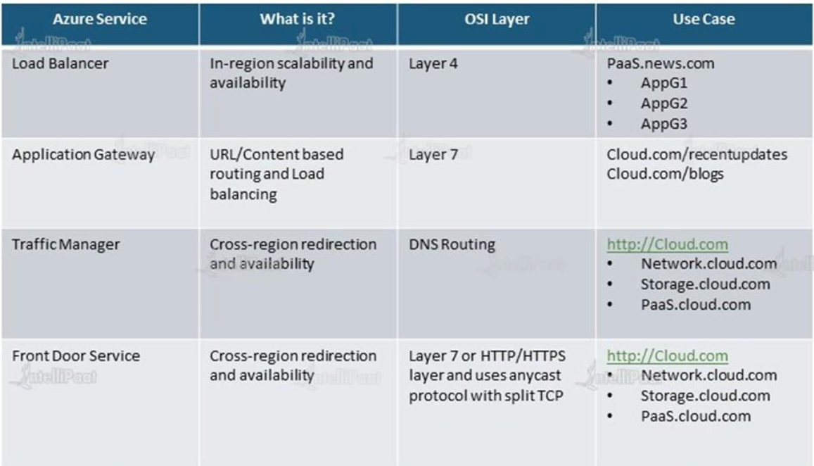

## LOAD BALANCER

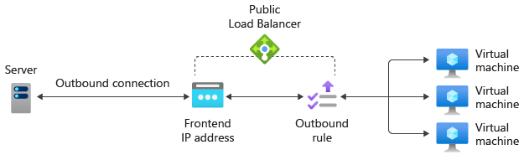

* The Load Balancer Service, distribute the user requests across the pool of resources (e.g., Azure virtual machines) to maintain availability.
* *The azure load balancer works on Layer 4(Transport Layer) and Application Gateway (Application Layer) of the OSO Model*

### LOAD BALANCER CONCEPT

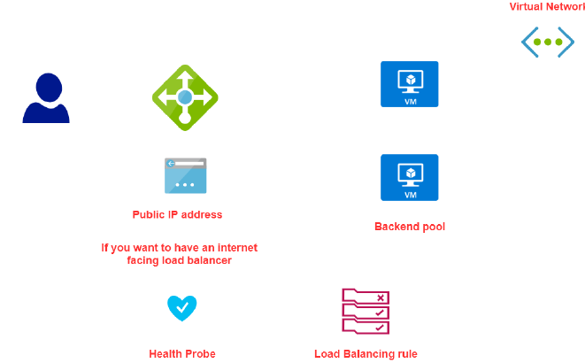

SCENARIOS TO USE A LOAD BALANCER

* INTERNET TRAFFIC : Balance the load of incoming traffic into a system of application
* INTERNAL NETWORK/ TRAFFIC
* PORT FORWARDING : Traffic can be forwarded to specific machine in the backend pool
* OUTBOUND TRAFFIC : Allow outbound connectivity for backend pool Vms

### COMPONENTS OF LOAD BALANCER

|  |  |
| --- | --- |
| **BACKEND POOL** | * When we create a load balancer, we specific the backend pool, which is a set of VMs to which the LB will route the traffic to. |
| **FRONTEND IP** | * The LB has a public IP address (called Frontend IP address). * The user can be able to access the VM via public IP of the load balancer. * The redirect of request from LB to VM are done via private IP of VM |
| **HEALTH PROBE** | * This helps the LB monitor the health of VMs in the backend pool |
| **LOAD BALANCING RULES** | * These rules drive how request can be distributed across the VM (which are part of backend pool) |

### LOAD BALANCER SKUs

* The Azure load balancer comes in 2 pricing model (SKU)
  + **BASIC LOAD BALANCER**
  + **STANDARD LOAD BALANCER**

|  |  |
| --- | --- |
| BASIC LOAD BALANCER | STANDARD LOAD BALANCER |
| *Free* | ***Charges on Per hour basis*** |
| *The VM in the backend pool must be part of availability set or scale set* | ***VM can be an independent machine that are part of a VNET*** |
| *Health Probes support TCP and HTTP only* | ***Health Probes support TCP and HTTP and HTTPS*** |
| *No support for availability zone* | ***Support for availability zone*** |
| *NO SLA* | ***SLA of 99.99%*** |

### TYPES OF LOAD BALANCER

There are 2 types of load balancer

1. PUBLIC LOAD BALANCER
   * A [public load balancer](https://learn.microsoft.com/en-us/azure/load-balancer/components#frontend-ip-configurations) can provide outbound connections for virtual machines (VMs) inside your virtual network.
   * These connections are accomplished by translating their private IP addresses to public IP addresses.
   * Public Load Balancers are used to load balance internet traffic to your VMs.
2. INTERNAL LOAD BALANCER

* An [internal (or private) load balancer](https://learn.microsoft.com/en-us/azure/load-balancer/components#frontend-ip-configurations) is used where private IPs are needed at the frontend only.
* Internal load balancers are used to load balance traffic inside a virtual network.
* A load balancer frontend can be accessed from an on-premises network in a hybrid scenario.

#### INTERNAL LOAD BALANCER

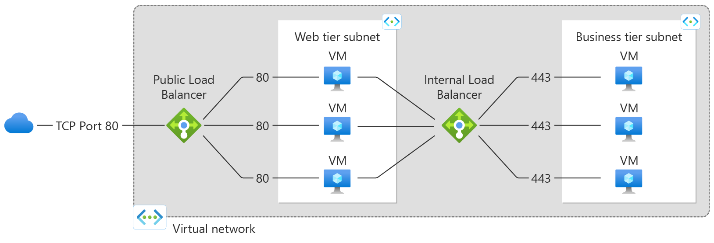

|  |  |
| --- | --- |
|  | * The internal load is used to direct traffic only between Azure’s internal resources i.e., the resources managed by Azure infrastructure or resources connected to Azure infrastructure using secure VPN * Internal load balancer can be used when want to divide the traffic to coming from other Azure Resources * It can also use internal load balancer or the traffic coming from on-premises network that is connected to an Azure resource via s secure VPN connection. |

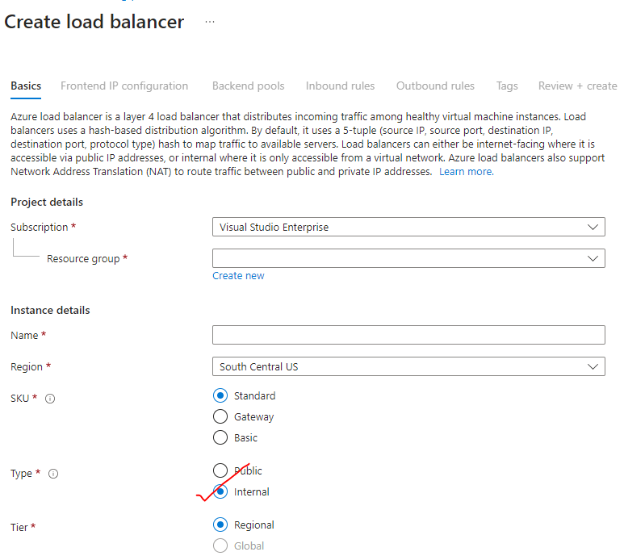

#### PUBLIC LOAD BALANCER

* Public load balancer is used to handle the traffic between public facing IP address of incoming traffic to private IP address of Azure resources.

### BASIC LOAD BALANCER (VMs in AVAILABILITY SET)

|  |  |
| --- | --- |
|  | * **The VM has to part of Scale set or availibility set** |

#### SETTING UP BASIC LOAD BALANCER (VM IN AVALIBILITY SET)

* ***STEP 1*:**
  + *We will create VMs, which will be a part of an* ***Availability Set (Make sure the VMs are part of same VNET)***
  + *The VM will have no public IP address as the communication between LB and VMs will be done via private IPs*
  + *Availability Sets can be used in conjunction with Azure Load Balancer to distribute traffic across multiple VMs within the set, providing load balancing and scaling capabilities.*
* ***STEP 2:*** *Install IIS with a Default.html page.*
* ***STEP 3:*** 
  + *Create a Public IP address (Note public IP address is a separate resource in Azure).*
  + *The Public IP will be assigned to the Load Balancer. Also known as* ***Front End public IP address***
  + *We can use Basic SKU of Public Ip for Basic load balancer & Standard SKU for Standard load balancer.*
* ***STEP 5:*** *Create a NSG which will be attached to at the subnet level of which VM is part of. Note – the NSG created with the VMs must be detached.*
* ***STEP 6:*** *Create and configure a Load Balancer resource. As part of configuration -we need to set up a Backend pool of the VMs created in Step 1*
* ***STEP 7:*** *Configure the health probe to check the health of VM in the backend pool*
* ***STEP 8:***  *Create Load balancing Rules – which will give the routing of request to the VM in backend pool*
* ***STEP 9:*** *Now we can be able send the request to load balancer via its public IP address, which will then redirect the traffic to VM in the backend pool.*

#### SETTING UP BASIC LOAD BALANCER (VM IN SCALE SET)

STEP 1: *We will create VMs, which will be a part of an* ***Availability Set***

**In this step**

1. **Port 80 has been enabled**
2. **ISS has been installed on the VM**
3. **After validation of IIS installation – Disassociate the Public IP address of VM**

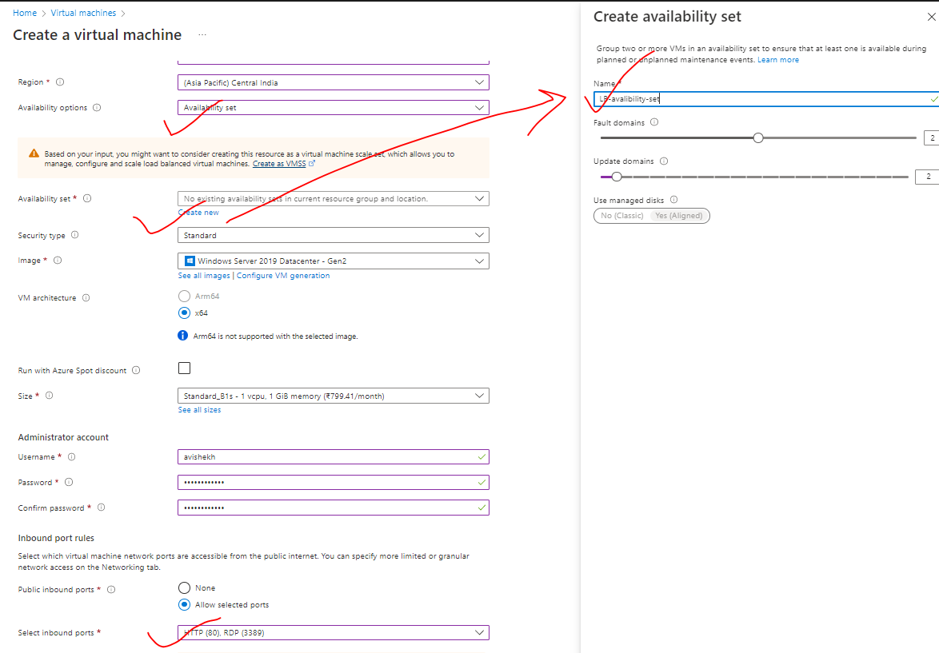

|  |  |
| --- | --- |
|  | * The communication between the Load balancer and the VMs in the backend pool – happens using private IP address. * For now – let’s keep the public IP address so that we can deploy IIS and validate it. * After that we can disassociate the public IP address from the VM as the communication between LB and VM are through private IPs |

**DISASSOCIATE PUBLIC IP FROM VM**

|  |  |
| --- | --- |
|  | 1. Go to VM 🡪 Networking 🡪Network Interface 🡪 IP Configuration 2. Disassociate the Public IP and make the provide IP as a static Ip 🡪 Save |

***STEP 3:*** *Create a Public IP address (Note public IP address is a separate resource in Azure). The Public IP will be assigned to the Load Balancer. Also known as Front End public IP address.* ***For basic load balancer the IP must be of type Basic SKU***

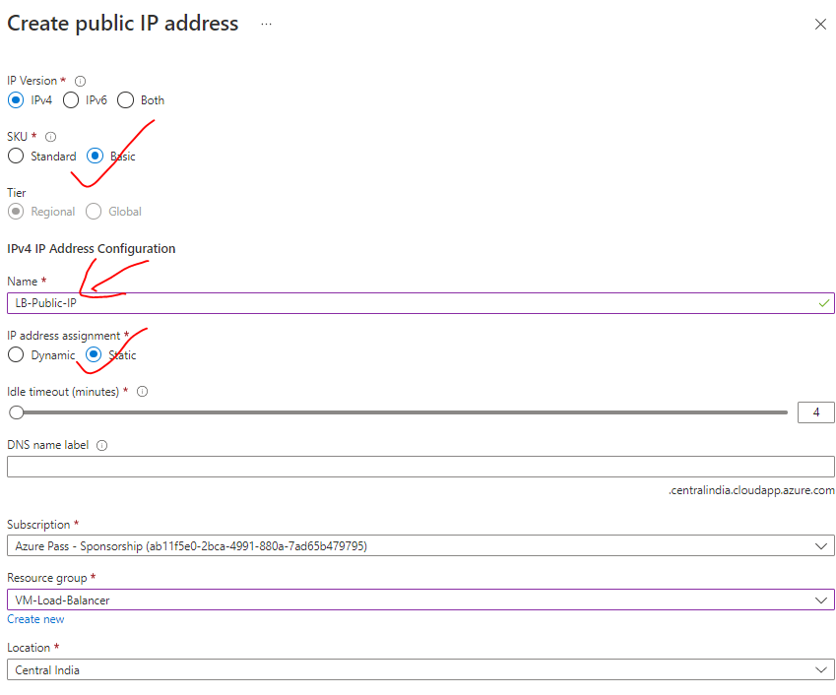

***STEP 4:*** *Disassociate the NSG associated with the VM*

1. Delete the NSG Rule

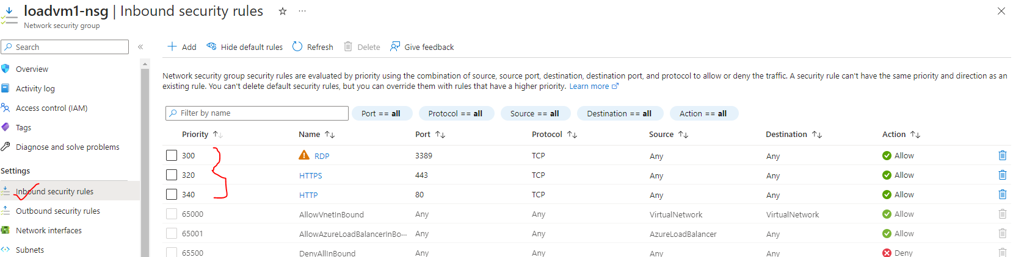

1. Disassociate the NSG from the NIC

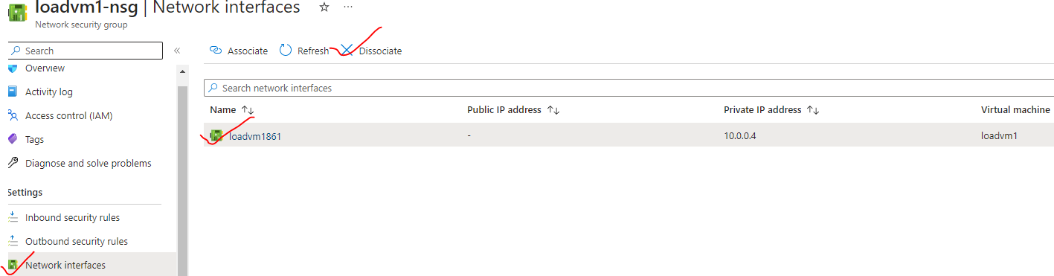

1. Delete the NSG

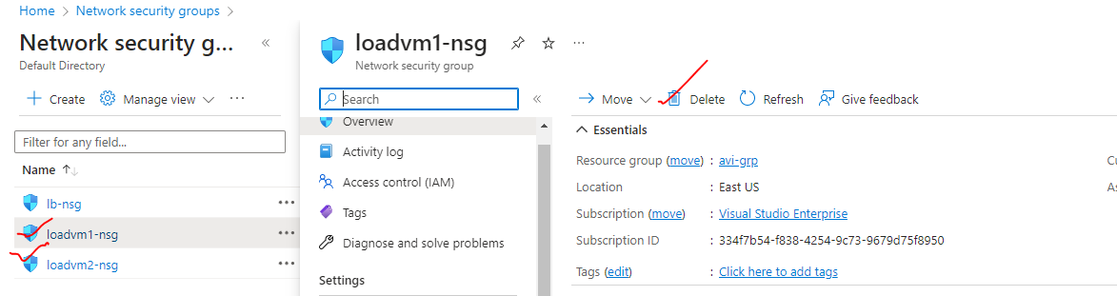

***STEP 5:*** *Create NSG and attach it to the subnet level of the VM.(Associate the subnet with the NSG)*

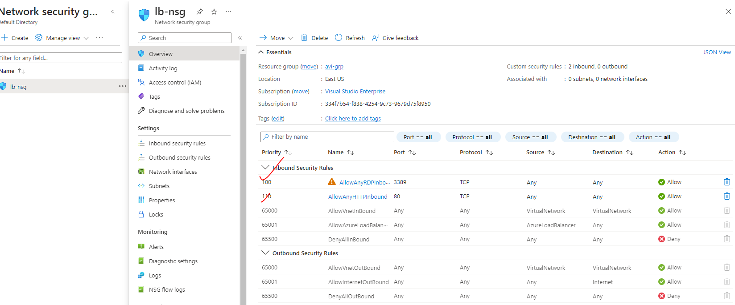

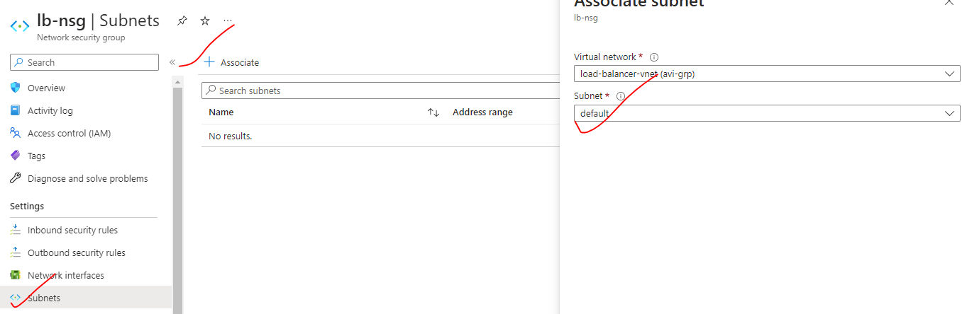

***STEP 7:*** *Create and configure a Basic Load Balancer resource. As part of configuration -we need to set up a Backend pool of the VMs created in Step 1*

|  |  |
| --- | --- |
| BASIC | FRONT END CONFIGURATION |
|  | Create the Load balancer  Note – Backend pool configuration can be done while configuring the LB  **TIER CONFIGURATION**  REGIONAL – VMs is a region will be load balanced  **GLOBAL –** VMs across multiple regions can be load balanced. |

##### LOAD BALANCER CONFIGURATIONS

###### CONFIGURING BACKEND POOL

|  |  |
| --- | --- |
|  | Add the VMs in the backend pool |

###### CONFIGURING HEALTH PROBE

|  |  |
| --- | --- |
|  | * After the interval of every 5 second – Load balancer will initiate a TCP handshake. if the VM acknowledge the TCP request – then the LB will know that VM is healthy |

###### CONFIGURING LOAD BALACING RULES

|  |  |
| --- | --- |
|  | * PORT- 80 - This setting is the port associated with the frontend IP that you want traffic to be distributed based on this load-balancing rule. * **BACKEND PORT** – It’s the Port in the VM which is the PORT of the IIS- This means – If the request comes to port number 80 of the load balancer (normal HTTP web request default port is 80) – then it will be distributing the traffic to backend pool port.   Load balancer rule reference diagram |

### LOAD BALANCER NAT RULES

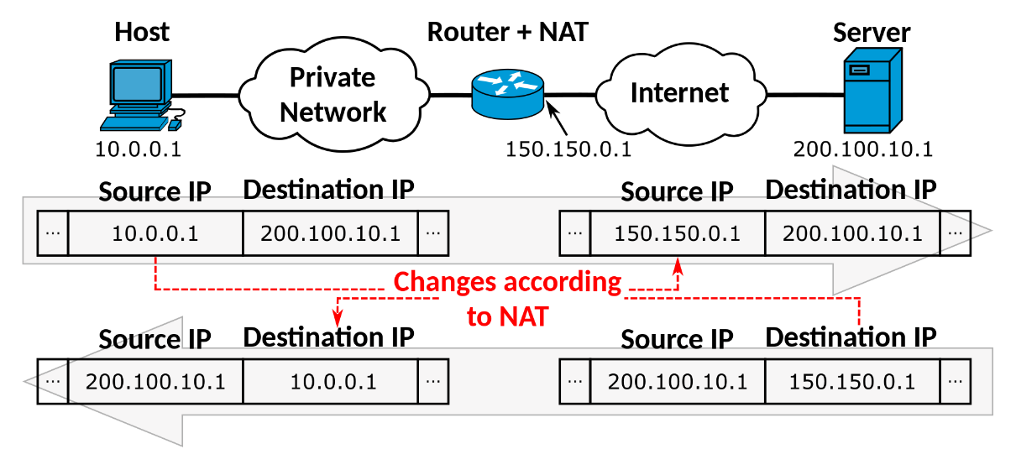

The primary purpose of NAT is to conserve public IP addresses, as the number of available public IP addresses is limited. With NAT, a router or firewall device sits between the private network and the internet, acting as a mediator. It translates the private IP addresses used within the local network to a single public IP address when communicating with external networks.

|  |  |
| --- | --- |
|  | * As the backend VMs don’t have public IP addresses, we can’t be able to connect these VM to internet or RDP onto these machines. * For such use cases, Load balancer provide option to connect to those VMs using its own public IP address, this is done with the help of ***NAT (Network Address Translation)*** * *Go to the load balancer 🡪 Inbound NAT rules 🡪 Add* * **Note- We need to add the NAT rules for all the connected VMs** |

* The Frontend port is a random port given for each connected VM. The will be used to connect (RDP) with the VM
* Backend port is the default port number for RPD

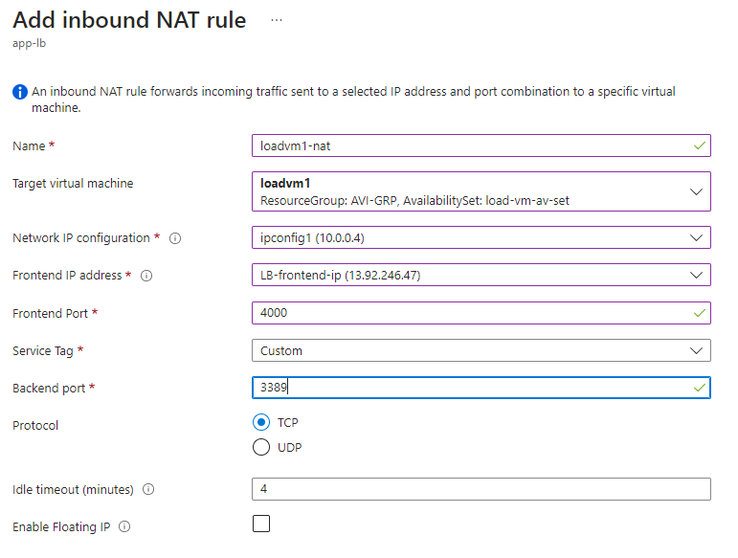

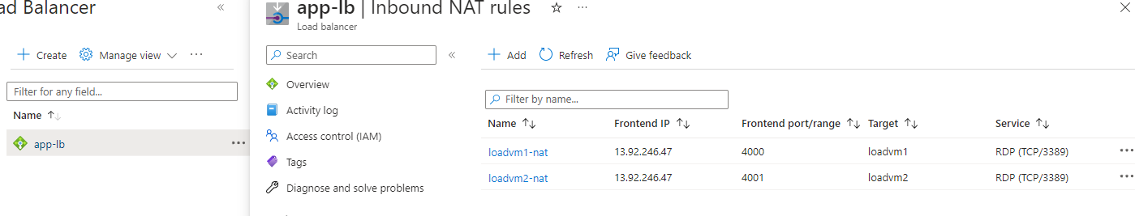

|  |  |
| --- | --- |
|  | * To connect with the respective VM we use   **<LOAD_BALANCE_FRONTEND_IP>:<FRONT END PORT CONFIGURED FOR THE VM>** |

### MUTIPLE BACKEND POOL AND FRONTEND IP ADDRESS OF LB

* The load balancer can have multiple frontend public IP addesss through which it can manage multiple backend pools using the load balacing rules
* <https://learn.microsoft.com/en-us/azure/load-balancer/load-balancer-multivip-overview>

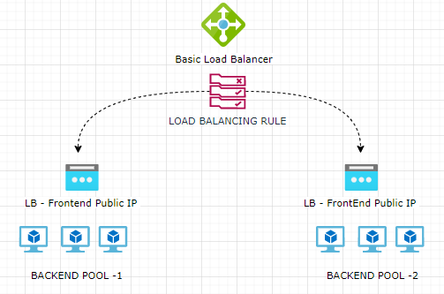

### BASIC LOAD BALANCER (SCALE SET)

#### STEP 1: CREATE A VM SCALE SET

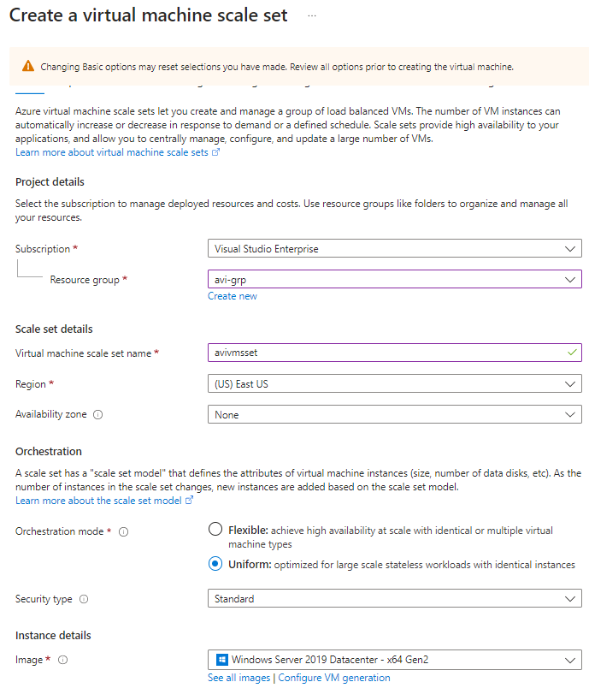

**NETWORKING**: Allow the HTTP & RDP ports

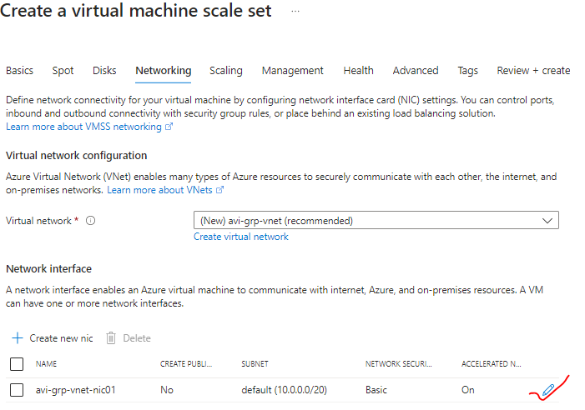

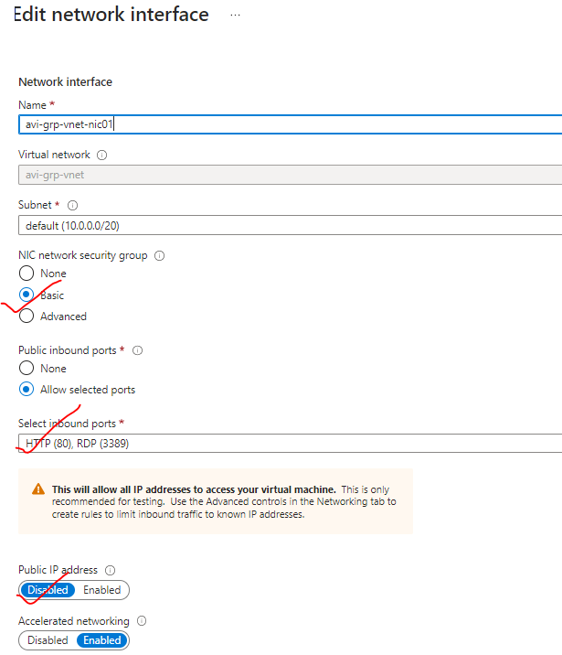

|  |  |
| --- | --- |
|  | * Let’s keep the initial instance count as :1 |
|  |  |

#### STEP 2: UPLOAD THE SCRIPT IN THE STORAGE ACCOUNT

* CREATE STORAGE ACCOUNT
* UPLOAD THE SCRIPT IN THE EXTENSION
* To install IIS on VM scale set – we can make use of ***custom script extension***. For that we need to **Create Storage Account and upload a script to install IIS**

|  |  |
| --- | --- |
| WINDOWS VM (installing IIS)  NEED TO CREATE POWERSHELL FILE – e.g – iis.ps1 | LINUX VM(install nginx)  Need to create Bash file : install_web.sh |
| import-module servermanager  add-windowsfeature web-server -includeallsubfeature  set-content -path "C:\inetpub\wwwroot\Default.html" -Value "<h1>Sever name: $($env:computername)</h1>" | apt-get update -y && apt-get upgrade -y  apt-get install -y nginx |

#### STEP 3: INSTALL CUSTOM SCRIPT EXTENSION AND RUN

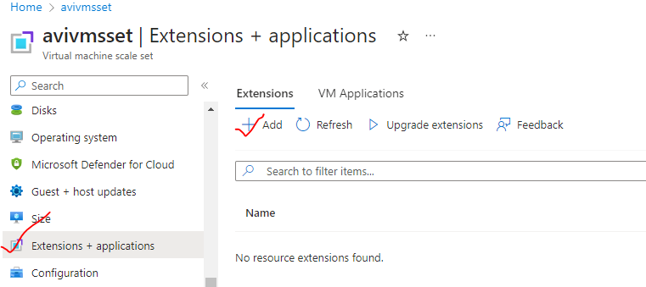

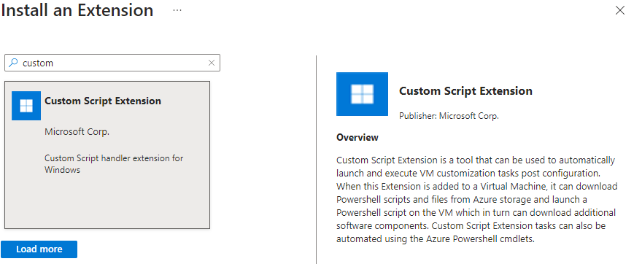

1. Browse the Storage account container (scripts)
2. Then select the script 🡪 Create

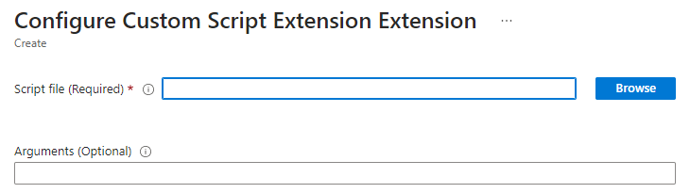

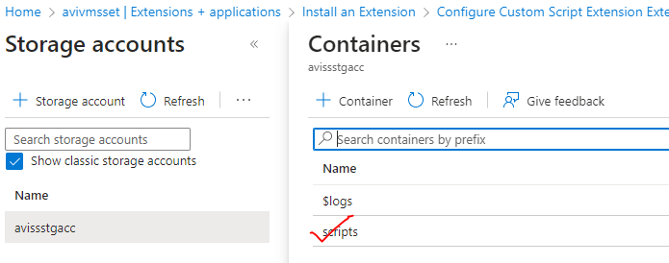

#### STEP 4: UPGRADE THE SCALE SET TO APPLY CUSTOM SCRIPT CHANGES

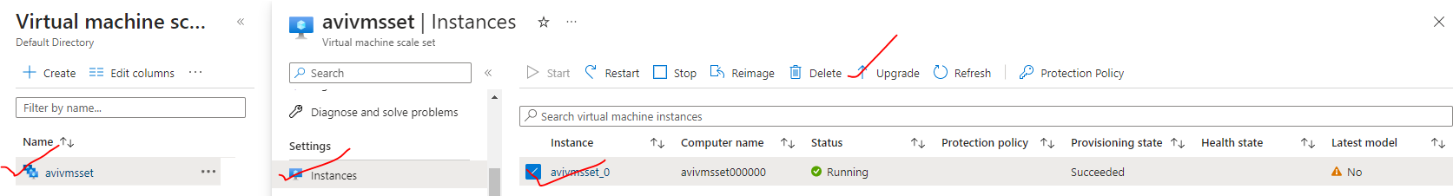

* **SET THE UPGRADE POLICY TO BE AUTOMATIC**

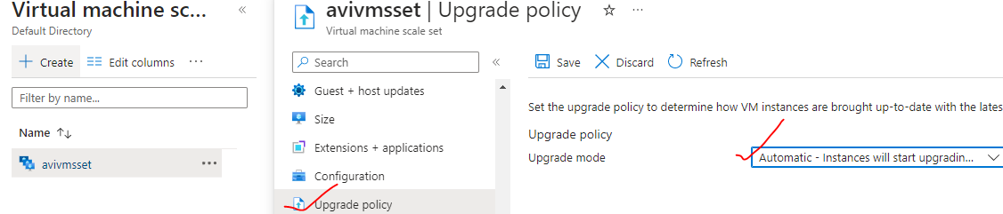

Since we setup the upgrade policy to Automatic – the scale set is showing Latest model as “Yes”

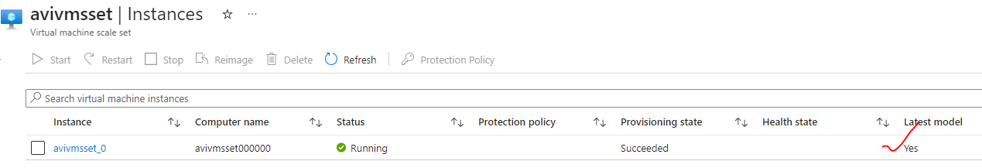

#### STEP 5: SET UP THE LOAD BALANCER

Create a basic load balancer. Configure the

1. Frontend IP
2. Public IP
3. Backend pool as VM scale set

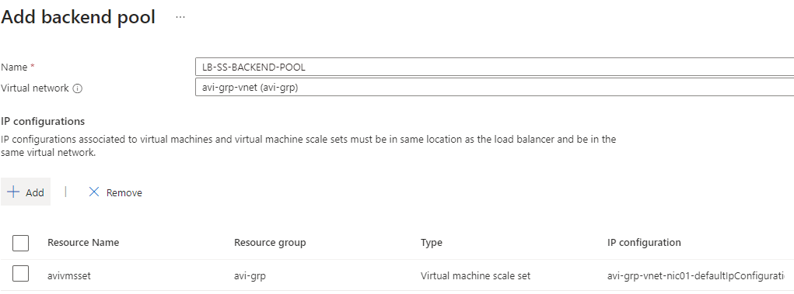

1. Set up the load balancing rule

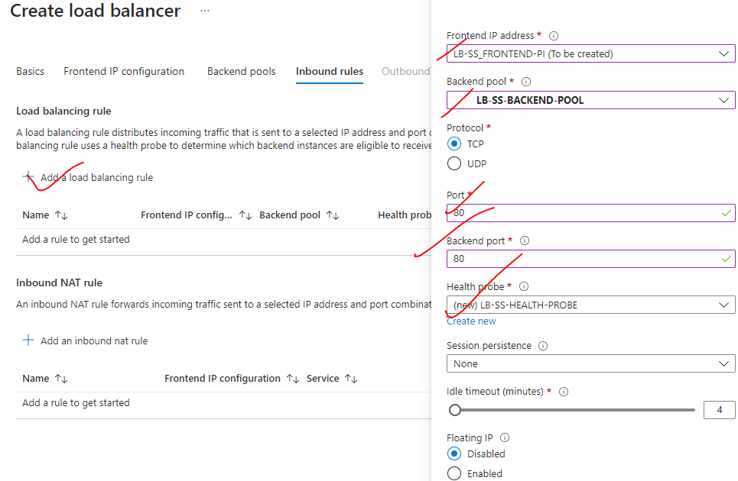

#### STEP 6: ACCESS THE VM IN THE SCALE SET VIA LB FRONT END IP

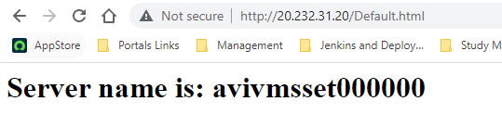

#### STEP 7: ADDING INSTANCES TO VM SCALE SET (MANUAL SCALING)

* While setting up the scale set we added just one instance to the scale set.
* To validate – whether the load balancer is load balancing the traffic withing the VMs of the Scale set – we can more instances.
* The new instance will be added on to the virtual machine scale set for that new instance. The custom script extension, installing internet information services and having the Default.html page in place at the same time.
* Along with that - the instance will be also reachable from the Azure load balancer.
* In the below example – lets increase the instance count = 2

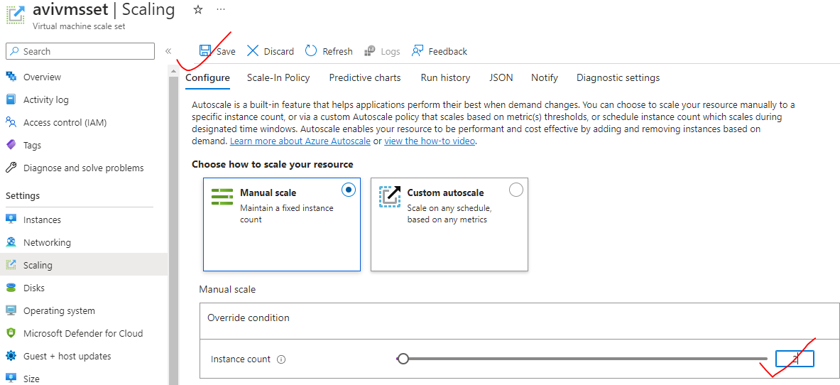

The instance will automatically get added to the backend pool of the load balancer

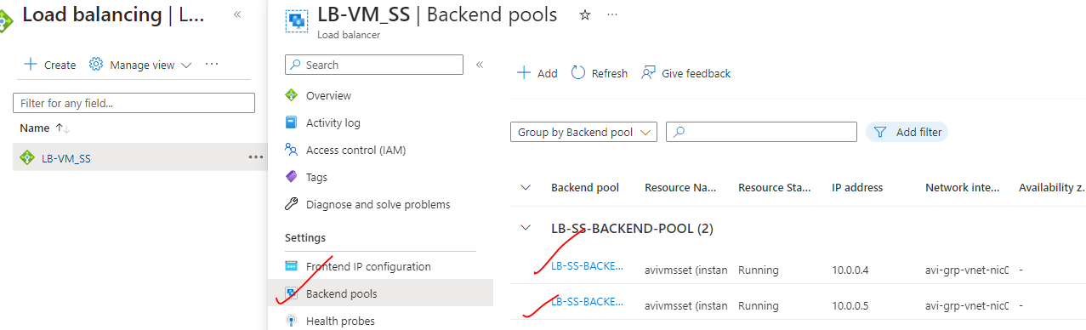

### STANDARD LOAD BALANCER

* Comparison between Basic and Standard load balancer: <https://learn.microsoft.com/en-us/azure/load-balancer/skus#skus>
* For high availability – we should choose Standard load balancer.
* ***For standard load balancer- any virtual machines or virtual machine scale sets, but they have to part of same virtual network***. They need not to be part of VMSS or Availability Set as needed in basic load balancer



#### SETTING UP STANDARD LOAD BALANCER

1. **Step 1: Create a Storage account and upload the custom script to install IIS to all VMs**

|  |  |
| --- | --- |
|  | **Step 2: Create 2 VMs**   1. The VMs will have no public IP address. 2. The VMs will have no NSG attached – we will create NSG as separate resource and attach it at subnet level. |
|  | **Step 3:**   1. Install the custom script extension. 2. Browse to the custom script in the storage account container |

**Step 4: Create the NSG**

1. **Add the inbound rule for HTTP and RDP traffic.**
2. **Attach it to the Subnet**

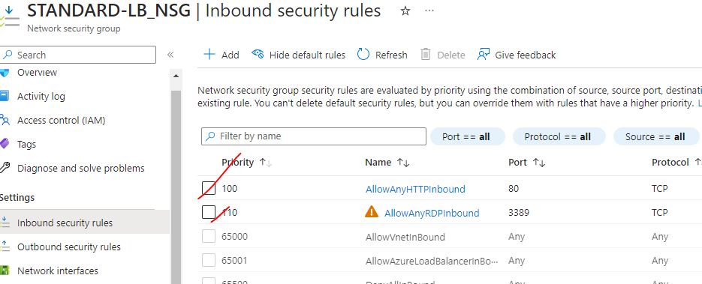

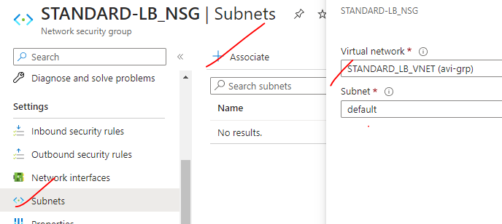

|  |  |  |
| --- | --- | --- |
|  | **STEP 5: CREATE THE LOAD BALANCER**  **Note – The Standard load balancer supports HTTPS health probe too.**  ***What's the difference between the TCP protocol and HTTP protocol in the standard load balancer?***  In HTTP health probe - The probe is going to make a HTTP request onto the path configured in the path. If it gets a response back, then it will consider backend instance has healthy. | |
|  | For the Standard load balancer:   * The public IP should also be of Standard SKU * The standard SKU creates a “***static public IP address***” | |
| **SET UP THE LOAD BALANCING RULE** |  | |
|  | | **INBOUND NAT RULES**   * To access the VMs using RDP – we need to configure the NAT rules. * We need to use the frontend IP of the Load balance for RDP   **<Public_ip>:<frontendport of vm>**   * By default, the outbound connection from the standard LB to internet will be disabled – which must be enabled explicitly |
|  | |  |

#### OUTBOUND RULE

* When we access the VM via LB’s public IP. The outgoing internet connection from the VM are disabled.
* To enable it we need to configure the outbound rule - ***Go to the Outbound rules of the LB*** 🡪 configure the following.

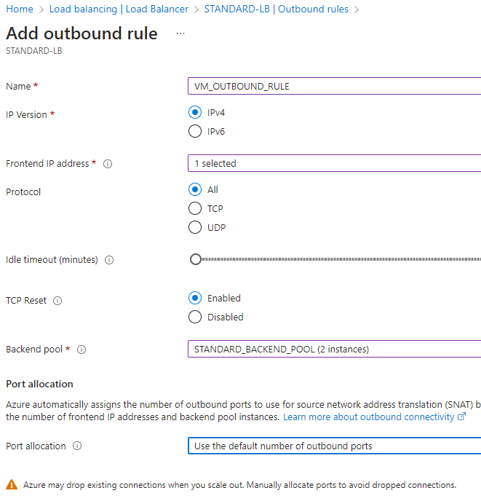

#### MULTIPLE BACKEND POOL

|  |  |
| --- | --- |
|  | * **The standard load balancer can have multiple backend pool.** * **To route the traffic to respective backend pool we can have dedicated frontend IP address.** |

To configure the Multiple backend pool

|  |  |
| --- | --- |
|  | Create a VM that can be added to the backend pool. |
|  | CREATE NEW FRONTEND IP FOR NEW BACKEND POOL |
|  | CREATE A NEW HEALTH PROBE FOR NEW BACKEND POOL |
|  | CREATE A NEW LOAD BALANCING RULE FOR NEW BACKEND POOL |

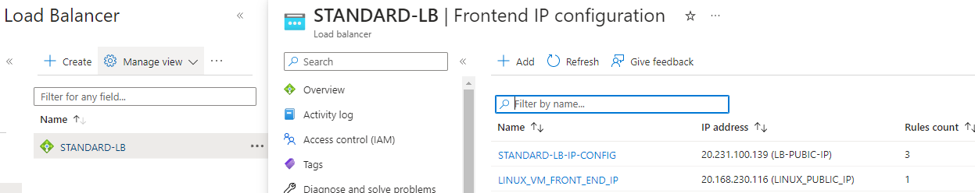

#### LOAD BALANCER SESSION PERSISTENCE

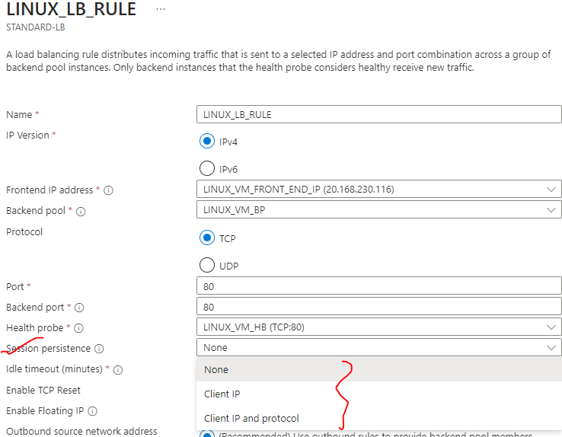

* Let's say that we have a user that has made a request via the load balancer on its frontend public IP address and the user has been directed on to load VM-1.
* If we **enable session persistence**, the load balancer will kind of create an affinity to the session between the load balancer and the client. Hence, this particular user for that particular session will always be directed onto load vm-1
* **ADVANTAGE**
  + Helps in better performance for the sessions itself. - if we don't want in a particular session the request to be distributed across the VMs
* **DISADVANTAGE**
  + But the disadvantage is if we have long sessions in those sessions – all the requests are directed towards loadvm-1 causing more load in loadvm-1) but load Vm2 may not be having that much load

#### LOAD BALANCER IN AVAILABILITY ZONE

Load balancing the resources (e.g. VMs) when they are deployed in a one single zone in availabilty zone or when they are distributed across multiple zones in Avalibility zone

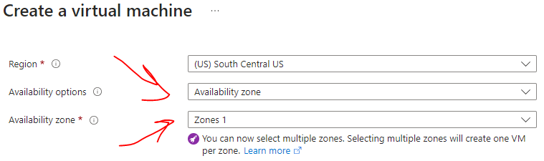

LOAD BALANCING – WHEN RESOURCES ARE SINGLE AVAILABILITY ZONE

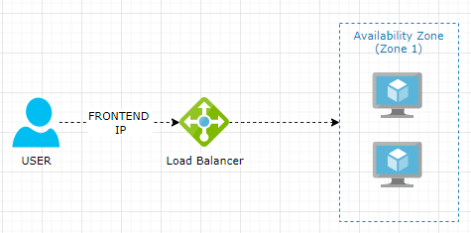

* In this case – the load balancer is also part for same availability zone.

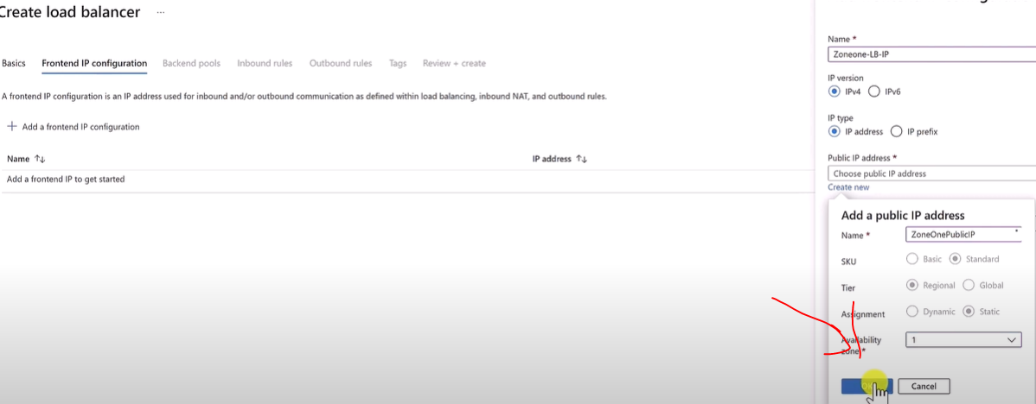

LOAD BALANCING – WHEN RESOURCES ARE DISTRIBUTED IN MULTIPLE AVAILABILITY ZONE

* The frontend IP will be Zone redundant.

|  |  |
| --- | --- |
|  |  |

#### GLOBAL / CROSS REGION LOAD BALANCER

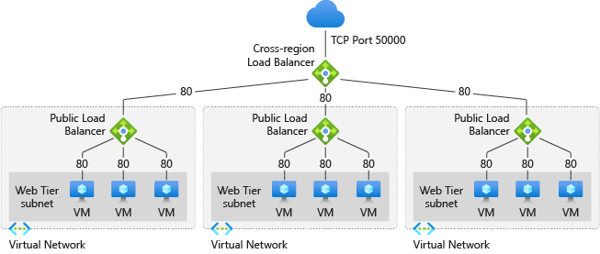

<https://learn.microsoft.com/en-us/azure/load-balancer/tutorial-cross-region-portal>

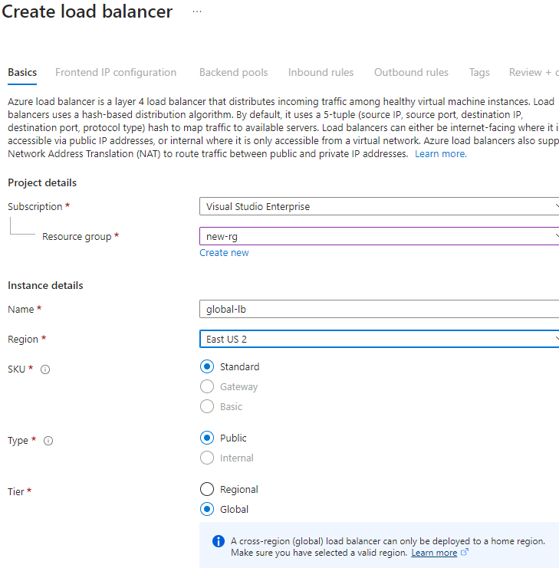

* The global load balancer can only be deployed to specific regions(Home Regions).
* List of home regions: <https://learn.microsoft.com/en-us/azure/load-balancer/cross-region-overview#home-regions>

**THE BACKEND POOL CONTAINS THE REGIONAL LOAD BALANCERS**

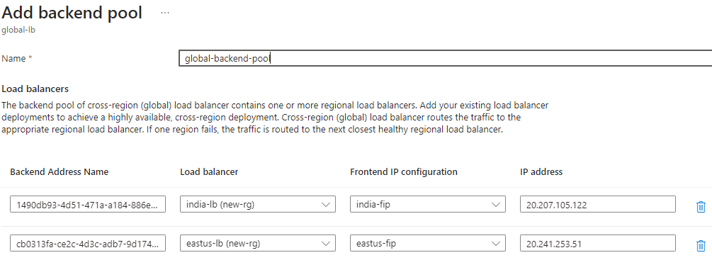

#### GATEWAY LOAD BALANCER

## AZURE APPLICATION GATEWAY

Application Gateway is

* Layer -7 (OSI Layer) load balancer
* Regional Solution -i.e., it is deployed to a specific region unlike Front-door is Global solution.
* As it’s a layer 7 load balancer – it has access to HTTP attributes and can make routing decision based on HTTP Attributes

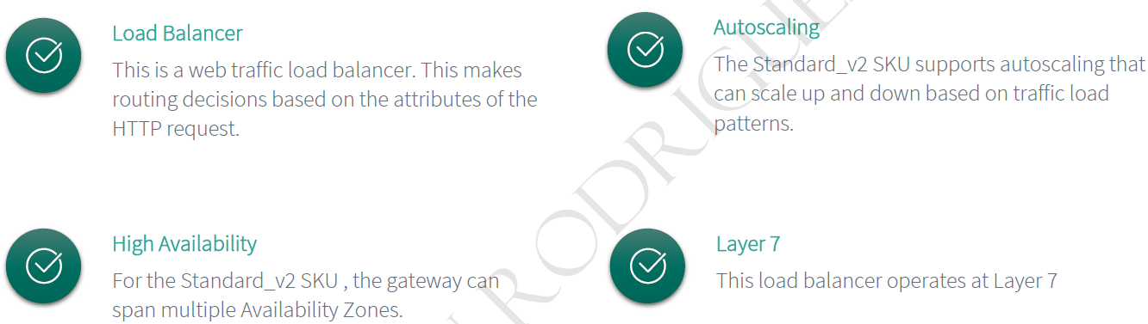

* **Azure Application Gateway is also enabled with Web Application firewall (WAF). It protects the applications against attacks which can be implemented on top of the Azure Application Gateway.**

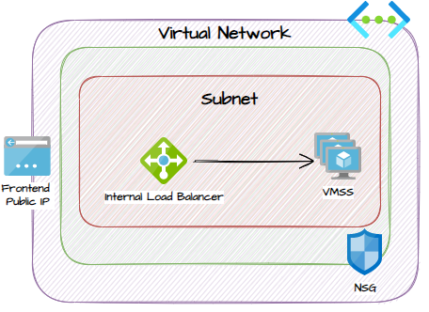

* The Application Gateway are deployed to a dedicated subnet. The reason it need it is “scaling”. Behind the scenes it creates VMSS for scaling. The VMs in the VMSS takes the IP from the subnet itself.
* As the App gateway is part of a Subnet – we can apply NSG at subnet level to restrict the traffic.

|  |  |
| --- | --- |
|  |  |

### APPLICATION GATEWAY FEATURES

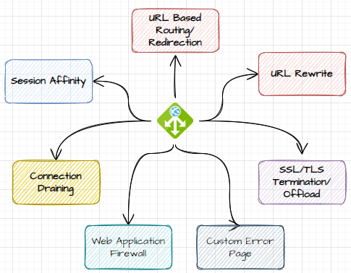

1. LOAD BALANCING
   * Application Gateway can distribute incoming traffic across multiple backend servers or instances based on various load-balancing algorithms, such as round-robin, least-connections, or session affinity. This helps improve application availability, scalability, and performance.
2. SSL TERMINATION
   * Application Gateway can handle SSL/TLS encryption and decryption, offloading the SSL processing from the backend servers.
   * It supports SSL termination at the gateway, which reduces the computational burden on backend instances and enhances performance.
3. WEB APPLICATION FIREWALL (WAF)
   * Application Gateway includes built-in Web Application Firewall (WAF) capabilities to protect web applications against common web vulnerabilities and attacks, such as SQL injection, cross-site scripting (XSS), and more.
   * The WAF rules can be customized and configured to meet specific security requirements.
4. URL-BASED ROUTING
   * Application Gateway supports URL-based routing, allowing us to direct traffic to different backend pools or services based on the URL path or host header.
   * **This enables routing requests to specific backend servers or services based on the requested URL**.
5. SESSION AFFINITY
   * Application Gateway can maintain session affinity or sticky sessions by directing subsequent requests from the same client to the same backend server.
   * This ensures that user sessions are maintained consistently during their interaction with the application.
6. HEALTH PROBES AND AUTOSCALING
   * Application Gateway continuously monitors the health of backend servers or instances using health probes. It automatically removes unhealthy servers from the load-balancing rotation and adds them back when they become healthy. Additionally, Application Gateway can scale up or down based on the configured autoscaling rules to handle varying traffic loads.
7. SSL OFFLOADING AND RE-ENCRYPTION
   * In addition to SSL termination, Application Gateway can also re-encrypt traffic before forwarding it to the backend servers, providing end-to-end encryption for increased security.
8. URL REWRITING AND REDIRECTION
   * Application Gateway supports URL rewriting and redirection rules, allowing you to modify or redirect incoming requests based on specific criteria.
   * This can be useful for scenarios like redirecting HTTP to HTTPS, rewriting URLs, or handling URL-based routing logic.
9. CONNECTION DRAINING

* Connection draining is a feature provided by Azure Application Gateway that ensures that active client connections are gracefully completed or drained before removing a backend server from the load-balancing rotation.
* When a backend server needs to be taken out of service, either for maintenance or due to an unhealthy state, connection draining allows existing connections to be gracefully terminated instead of abruptly closing them.

1. CUSTOM ERROR PAGES

* Custom Error pages may be created instead of showing default Microsoft error pages.

### APPLICATION GATEWAY COMPONENTS

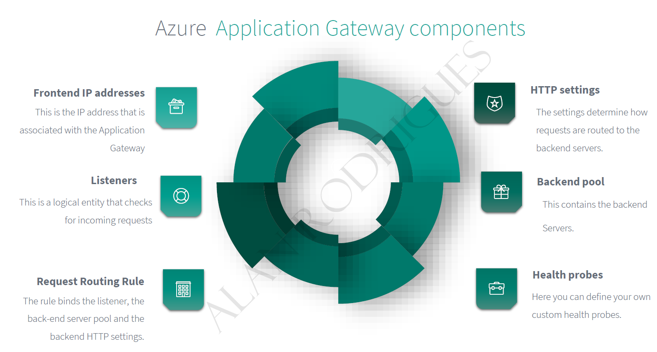

1. As the application Gateway a routing service so instead of users directly going on to the applications hosted in the backend pool (like VM, VMSS, Web app or On Premises), they make request to the frontend public IP address of Azure Application Gateway. *Note –* ***The frontend public IP address can have DNS name.***
2. In App gateway’s backend pools can be VMs, VMSS, Azure Web App and On Prem App servers.
3. We can have one or more listeners -so that it can listens for user requests configured on App Gateway
4. The rules in the App gateway defines how the traffic is routed onto the backend pool.
5. The settings define the configuration of the backend pool. For example - if we want secure requests on services in the backend pool, we can define as part of HTTP settings.

### HOW APPLICATION GATEWAY WORKS?

1. **AS EXTERNAL LOAD BALANCE** - When the user sends the request to the application gateway (public frontend IP of the application gateway)- then he users has to use the public DNS resolver in order to be able to get the public IP address of the application gateway.
2. **AS INTERNAL LOAD BALANCE -** In case when we use application gateway as an internal load balancer- then we can use private IP address(for frontend IP of App gateway) we can able to use a custom DNS resolver to be able to resolve the private IP address of application Gateway.
3. The Listeners checks for a connection, requests coming from the users- The listeners can be either Http or Https listener based on the traffic which can encrypted or unencrypted.
4. **ROUTING RULES** - Routing rule on a particular listener defines – which request which land on which backend pool
5. And in order to maintain the second part of the connection between the application gateway and the backend
6. pools, the application gateway needs to use Http settings, whether it's Http or Https.
7. There are two scenarios we are going to talk about in here in future.
8. Whether you prefer to have an encrypted traffic between the application gateway and the backend pools,
9. or you are going to have an unencrypted traffic based on your preference.
10. And you may have noticed here there is a firewall configuration, which is a key thing.
11. Generally speaking, the application gateway comes with two categories, whether it's a standard or
12. WAF.
13. WAF stands for Web Application Firewall, and there are two versions under each of them version one
14. and version two.
15. And if you have chosen to go ahead with the Web version, what's going to happen is that the Application
16. gateway is going to assess the incoming requests to see if there is any security threats on those requests
17. before it will start applying the routing rules on those requests and before start to directing these
18. requests to the back end targets.
19. This is a way to protect your back end targets or to use the application gateway as a web application
20. firewall or as a WAF.
21. And we are going to cover the WAF version of the application gateway in more details later.
22. Also, I want you to be aware of that application.
23. Gateway does some modifications to the Http requests coming through the application gateway by adding
24. five additional headers to the requests.
25. And these are the five additional headers.
26. You just need to be aware of them in case you are going to need them in the future to do some tracing
27. or diagnosing for any issues that might happen between the application gateway and the back end targets.
28. That was a very high level overview of how the application gateway works.
29. And in the next videos we are going to dive deep into each of these components to understand how it
30. actually works to direct the traffic to the backend targets.
31. And we are going to see the other options you could play around with.
32. That's all I have for you in this video.

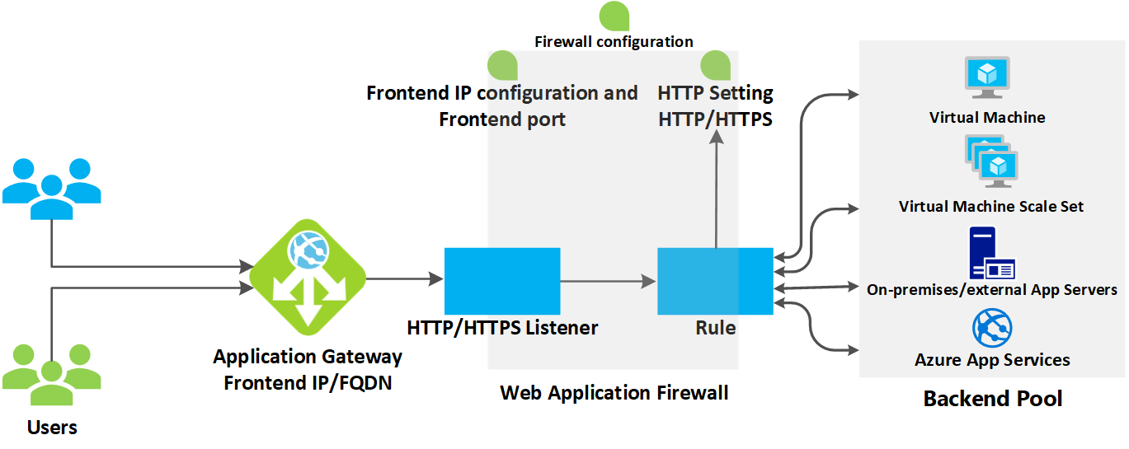

|  |  |
| --- | --- |
| **BACKEND POOL** | In the backend pool we can have   1. **VM & VM SCALE SETS** 2. **WEB APP** 3. **ON PREM SERVERS** |
| **FRONTEND-IP** | * Public IP of load balancer |
| **HTTP/HTTPS LISTENER** | * HTTP listeners play a crucial role in Azure Application Gateway by **acting as the entry points for incoming HTTP traffic**. * They define how the Application Gateway handles and routes requests received on specific ports and URLs.   **KEY ROLES OF HTTP LISTENERS IN APPLICATION GATEWAY**:   * PORT AND PROTOCOL BINDING: HTTP listeners are associated with specific ports and protocols (HTTP or HTTPS). They define the IP address and port on which the Application Gateway listens for incoming HTTP traffic. This allows the Application Gateway to handle requests for specific ports and protocols as defined by the listener configuration. * HOSTNAME-BASED ROUTING: HTTP listeners can be configured for hostname-based routing. They allow requests with different hostnames (e.g., [www.example.com](http://www.example.com/), api.example.com) to be routed to different backend pools or services based on the specified routing rules. This enables the Application Gateway to direct traffic to the appropriate backend based on the requested hostname. * PATH-BASED ROUTING: HTTP listeners support path-based routing. They enable requests with specific URL paths (e.g., /api, /images) to be routed to different backend pools or services. This allows for granular control over routing based on the requested path. * REQUEST ROUTING: HTTP listeners are associated with routing rules that define how the incoming requests should be forwarded to the appropriate backend pool or service. These rules can be based on hostname, path, or other conditions specified in the routing rules. HTTP listeners play a crucial role in determining the initial routing decision for incoming requests. |
| **RULES** | * These rules decide how the traffic is routed to backend pool. |
| **HTTP/HTTPS SETTINGS** | This setting determines how the traffic will be routed to backend pools |

### APPLICATION GATEWAY – PATH BASED ROUTING

* As App gateway is a layer 7 load-balancer. It will all different HTTP request attributes. Hence this information helps in routing the traffic based on path

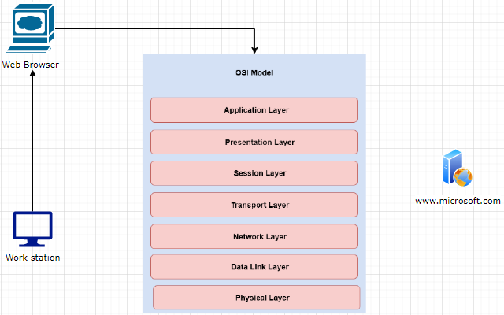

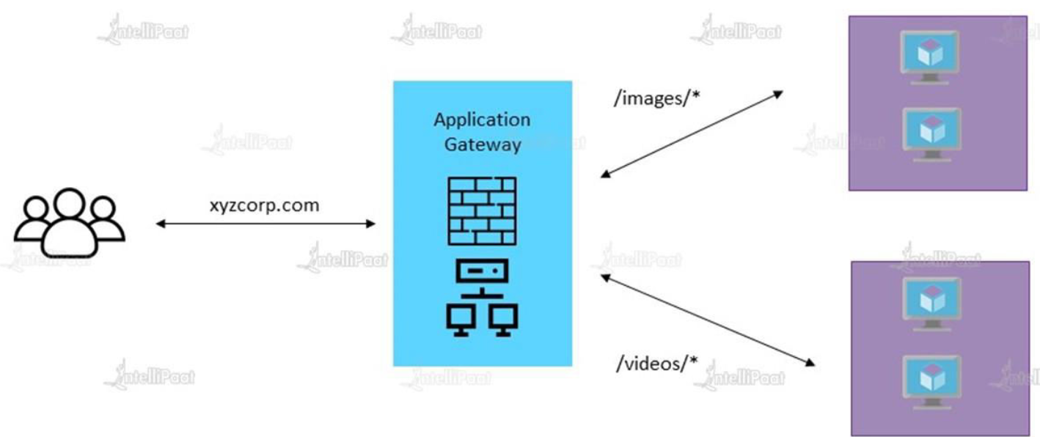

* **In the Azure Application Gateway – we have another feature which we can enable known as the Web Application firewall to protect the web applications from Internet based attacks.**

### SETTING UP APPLICATION GATEWAY – URL ROUTING

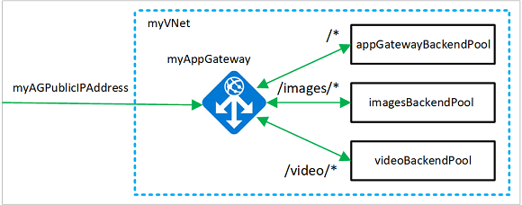

#### STEP 1: SET THE VMS

* Create 2 VMs. Let’s call it as imagesVm and videosVm
* Install IIS in both VMs .
* Create a images folder in imagevm and place Default.html
* Create a videos folder in videovm and place Default.html

***With this set up – request via Application gateway frontend ip to the path “/images” will be routed to “imagevm” and “/videos” will be routes to videovm***

#### STEP 2: CREATE EMPTY SUBNET FOR APPLICATION GATEWAY

* Before deploying Application Gateway - we have to add a new subnet (empty subnet) In the VNET, (Note - VMS are deployed in default subnet)

NOTE:

* The Application Gateway is going to deploy its own compute machines, its own resources on to this empty subnet. These resources are required for the routing of traffic to the back-pool.
* Since App gateway is layer -7 load balancer - that means it needs to process the request, and then do the routing accordingly. That’s why it need an infrastructure (managed by Azure itself)

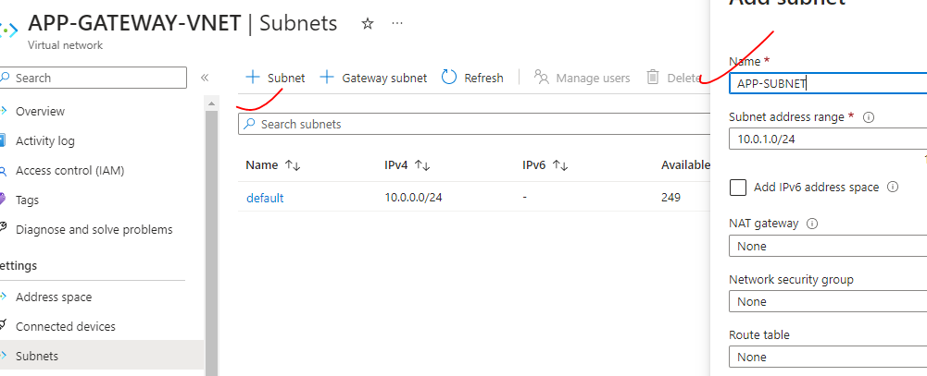

#### STEP 3: DEPLOY APPLICATION GATEWAY

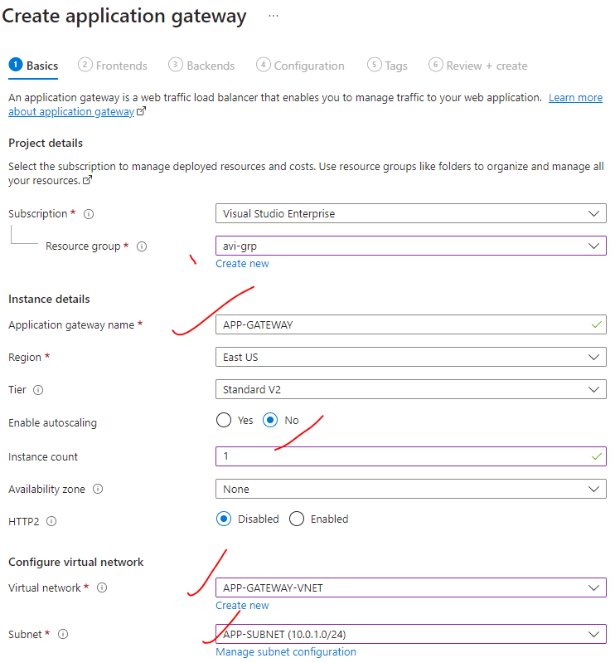

|  |  |
| --- | --- |
| AUTOSCALING | * The Application Gateway is going to deploy its own compute machine in the subnet where it is deployed. Hence – when demand increases it automatically scale up the amount of compute resources.(VMS) in the same subnet |

##### SET UP PUBLIC IP ADDRESS

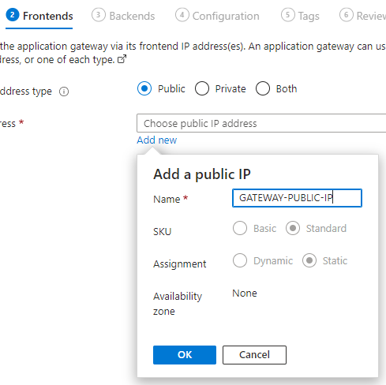

##### BACKEND POOL

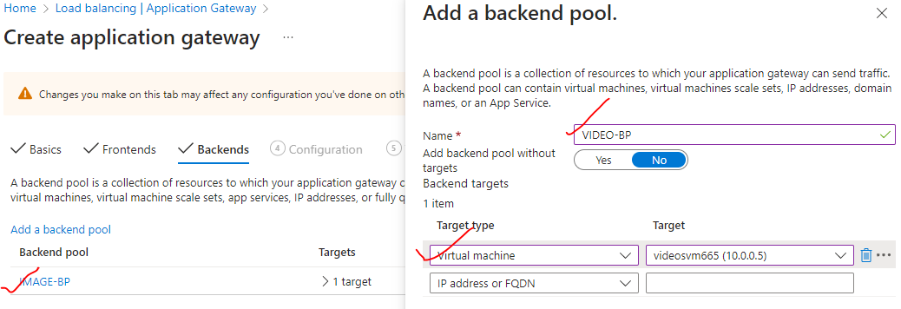

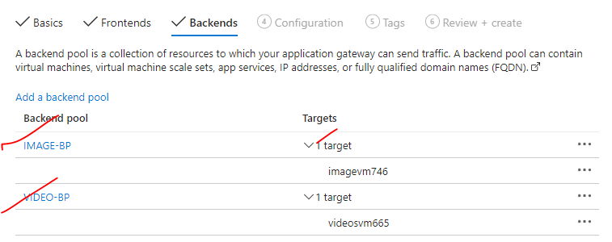

##### SET UP THE ROUTING RULES

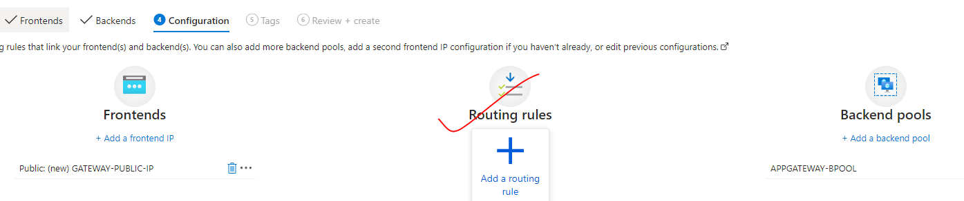

|  |  |
| --- | --- |
|  | * So here we have two types of listeners.   + BASIC LISTENER: Listens to just one domain name.   + MULTISITE: Listens on multiple domain names.   PATH CONFIGURATION |
|  | |

### APPLICATION GATEWAY WITH WEBAPP (URL ROUTING)

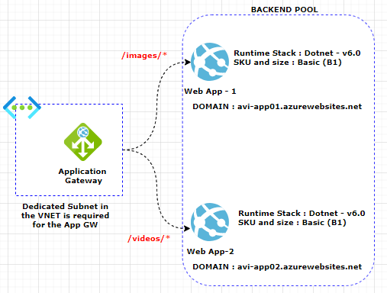

|  |  |  |  |
| --- | --- | --- | --- |
| 1. Step 1: SET UP 2 WEBAPP   *Create images and videos folder in respective app with a default .html* | |  |  | | --- | --- | |  |  | |

1. **UPDATE THE BACKEND SETTING**

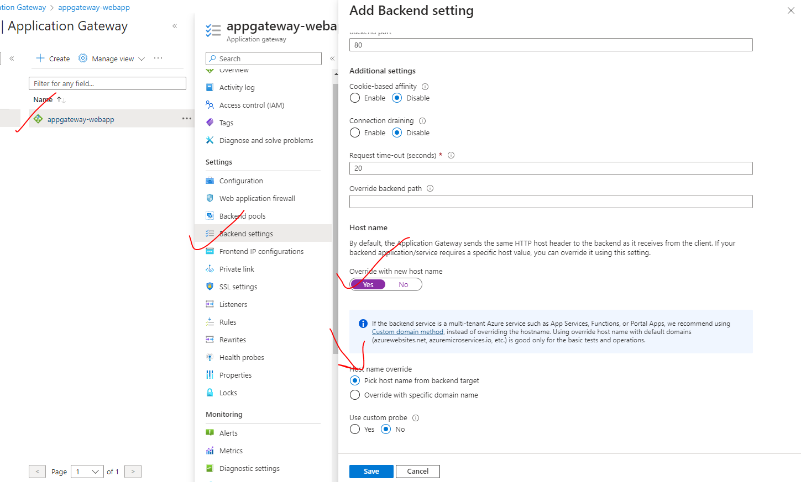

### APPLICATION GATEWAY – REWRITE

* Azure Application Gateway Rewrite Rules are used to modify or transform the URLs of incoming HTTP requests before they are sent to the backend servers.
* These rules allow for URL manipulation and can be helpful in scenarios where we need to adjust or rewrite URLs to match the expected format of the backend resources.

KEY ASPECTS OF THE REWRITE FEATURE IN AN APPLICATION GATEWAY:

1. URL PATH REWRITING: Rewrite Rules can modify the URL paths of incoming requests. This includes adding, removing, or replacing segments of the URL path.
2. HOSTNAME REWRITING: Rewrite Rules can also modify the hostname or domain of the incoming requests. This allows for changing the destination host for the request.
3. QUERY STRING MANIPULATION: Rewrite Rules can modify or add query string parameters in the URL. This can be useful for appending or modifying parameters required by the backend resources.
4. REDIRECTS AND FORWARDING: Rewrite Rules can be used to redirect or forward requests to a different URL. This can be helpful in scenarios where the original request needs to be sent to a different endpoint.
5. REGULAR EXPRESSION SUPPORT: Rewrite Rules support regular expressions for advanced pattern matching and transformation. This provides flexibility in defining complex rewriting rules based on specific patterns.
6. RULE ORDER: Rewrite Rules are executed in a specified order. You can define the priority or precedence of the rules to ensure they are applied in the desired sequence.
7. CONDITION-BASED REWRITING: Rewrite Rules can be conditionally applied based on specific conditions. This allows for more granular control over when the rewrite rules are executed.
8. TESTING AND DEBUGGING: Azure Application Gateway provides the ability to test and debug Rewrite Rules using the Rewrite Rule Tester. This allows you to verify the behavior and outcome of the rewrite rules before applying them in a production environment.

#### SETTING UP REWRITE FOR APP GATEWAY

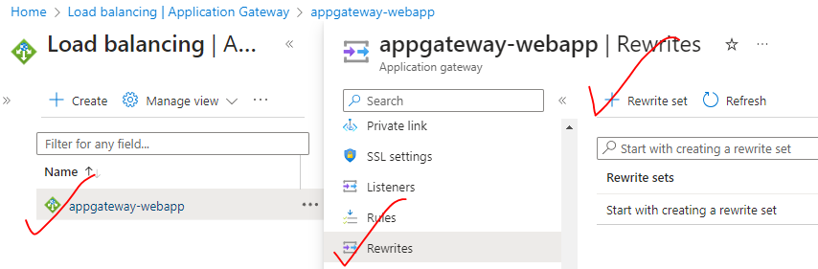

SELECT THE BACKEND TARGETS WHERE WE WANT TO SET UP THE REWRITE FOR

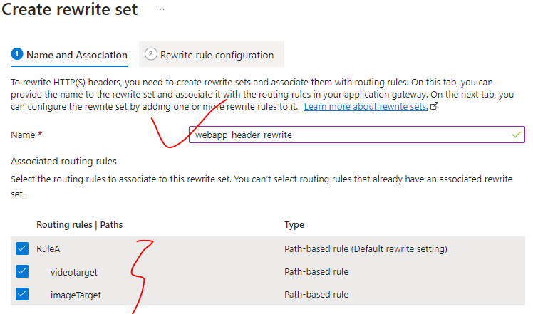

Click on Add Rewrite Rule🡪 Give a name to the rewrite

USE CASE: WE WANT TO SET A CUSTOM HEADER IF THE RESPONSE HEADER HAS CACHE-CONTROL: NO-CACHE

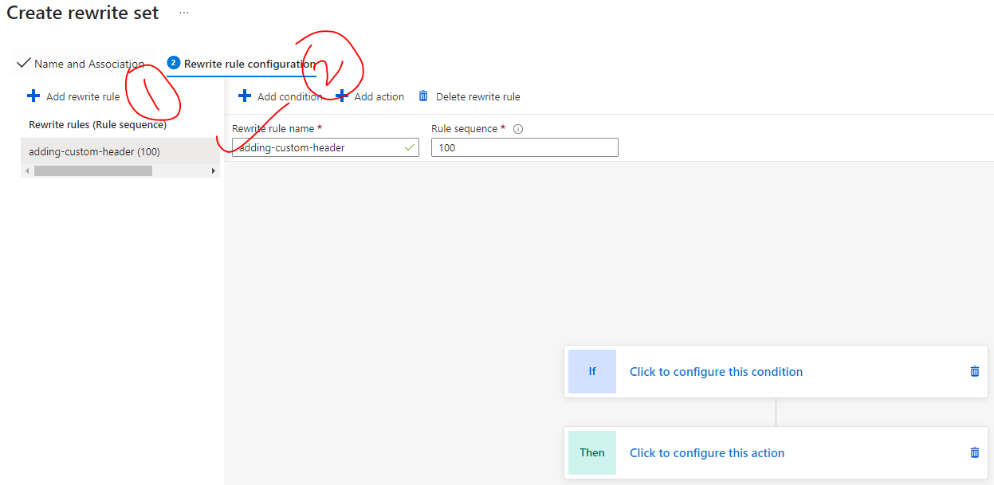

IF (CONDITION) AND THEN (ACTION)

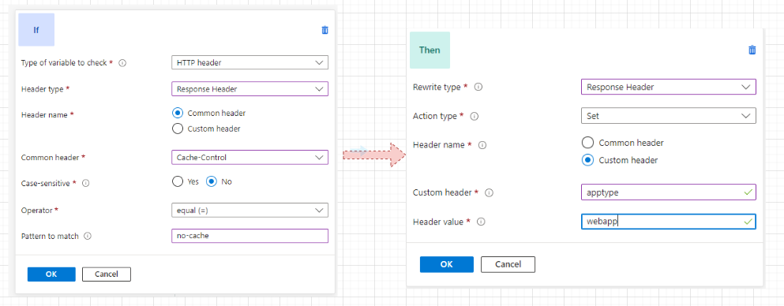

### APPLICATION GATEWAY – REDIRECTION

### MULTISITE

* Multi-site hosting is a feature provided by Azure Application Gateway that allows us to **host multiple websites or web applications behind a single Application Gateway**.
* With multi-site hosting, we can configure the Application Gateway to route incoming traffic to different backend pools based on the host name or URL path specified in the client request.

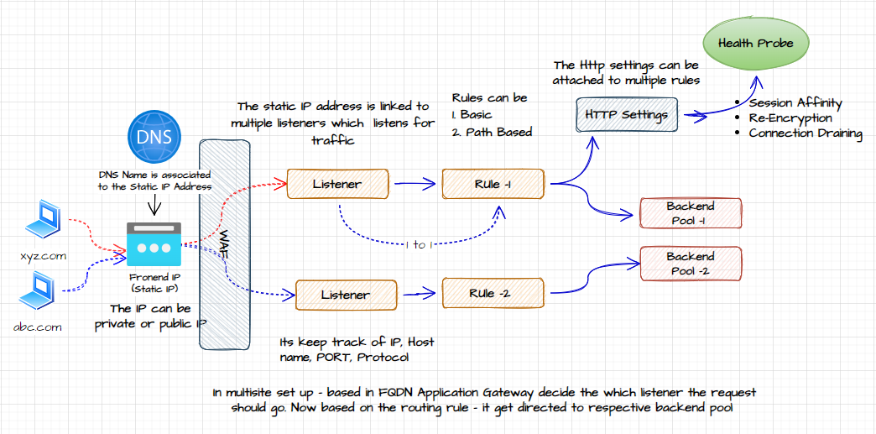

#### HOSTING MULTIPLE SITES

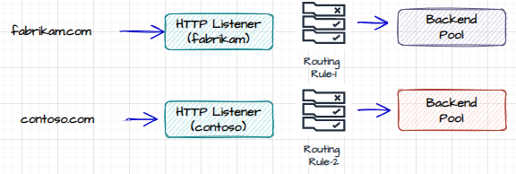

1. Step 1: Create backend pool (VMs) for each site. Install IIS on each VM
2. Step 2: Provision the Application

## USER DEFINED ROUTES

* In a virtual network- which has multiple subnets – we can have VMs located in each subnet. By default, they can communicate with each other(using private IP).
* In the VNET - this is a default system route that tells the packets of information how to be routed onto or how

to be routed from the source on to the destination virtual machine within the same virtual network itself.

* These default system routes are configured at the Network interface of the VMs. Similar to below we can create our own routes.

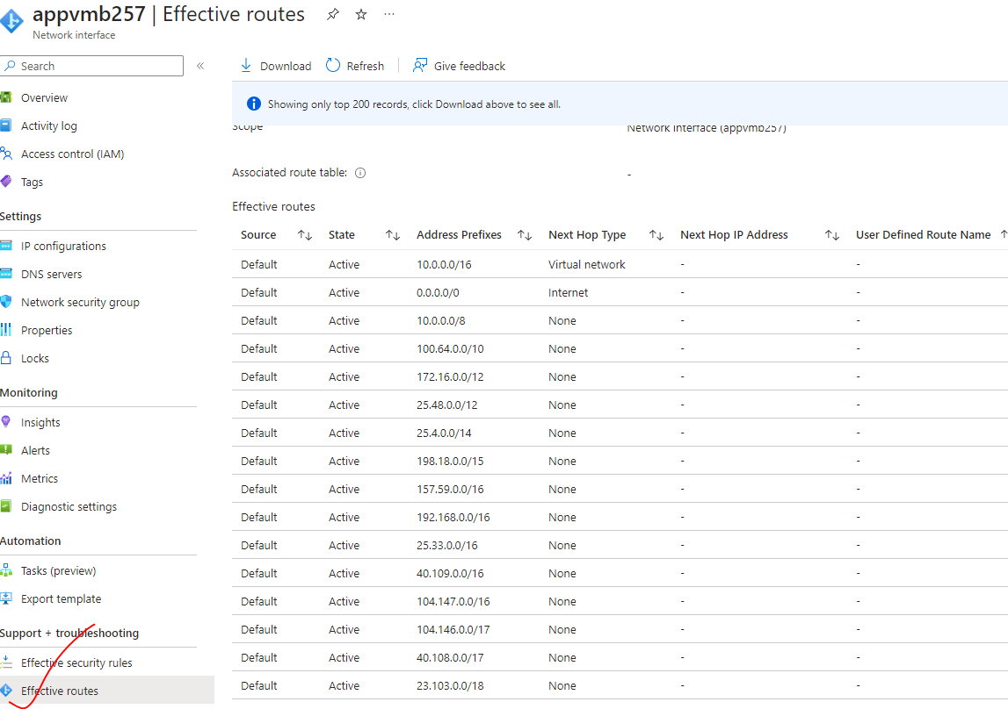

### USECASE - SETTING UP USER DEFINED ROUTE

|  |  |
| --- | --- |
|  | * **The objective of setting up the user defined route is that traffic from appvmA to appVmB has to go via centralVm** * The can be accomplished using User defined route * **Note – All the VM within a VNET can communicate with each other via their private IP address** * We don’t have to enable the NSG for PORT “80” as within the the VNET . This VNET rule is need when the VM are getting accessed from internet. |
| * The “AllowVnetBound” is the default NSG rule which allow the communication with VNET (even with private IP address) | |

#### STEP TO SETTING UP USER DEFINED ROUTE

1. CREATE A VNET (APP-VNET)
2. CREATE SUBNET AND ATACH A VM TO EACH SUBNET

|  |  |  |
| --- | --- | --- |
| VMs | SUBNETs | PUBLIC IP ON VM? |
| appVmA | SubnetA | No (private ip - 10.0.0.4) |
| appVMB | SubnetB | No( private ip - 10.0.2.4) |
| CentralVM | CentralSubnet | Yes + INSTALL IIS(private ip - 10.0.1.4) |

#### STEP 2: CREATE THE VNET

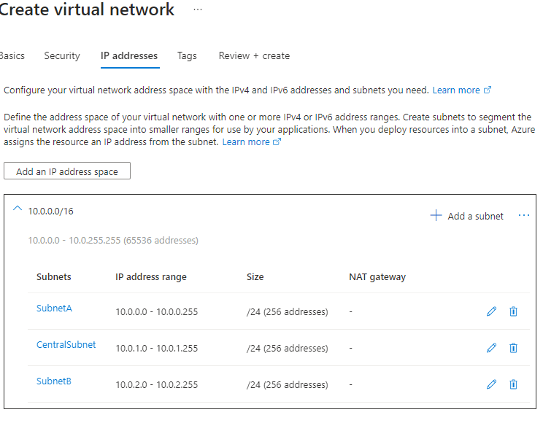

#### STEP 3: CREATE THE ROUTE TABLE

* Create a “Route table” resource.
* Defined the route in the route table
* Associate the rout with the subnet

CREATE A ROUTE TABLE

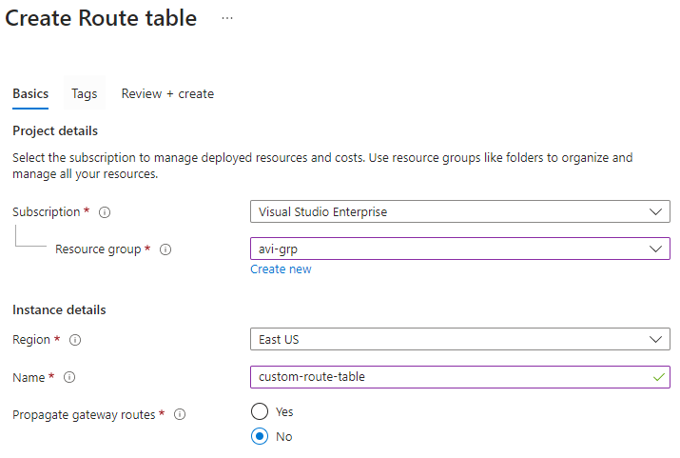

ADDING A ROUTE

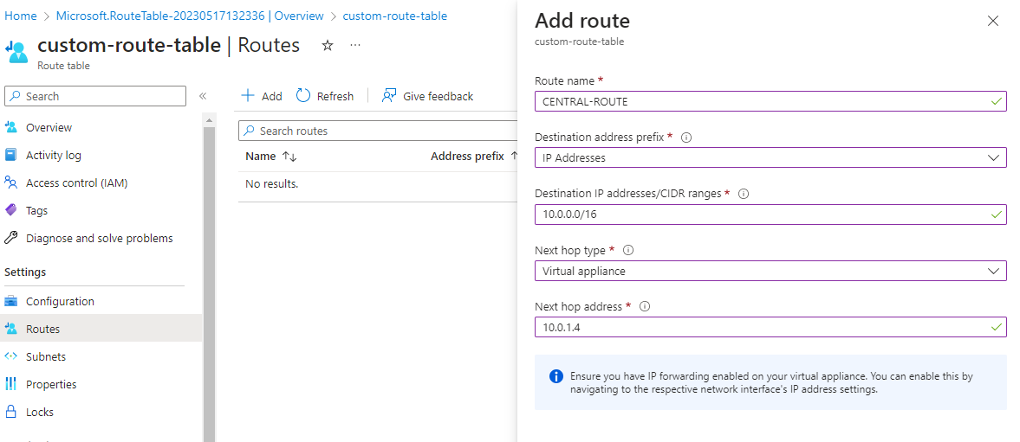

ASSOCIATE A SUBNET WITH THE ROUTE

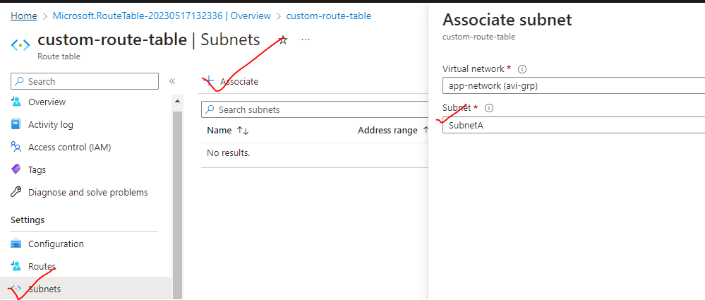

* Associate both SubnetA and SubnetB with the route

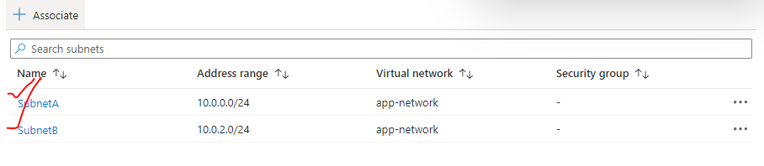

#### STEP 4: ENABLE FORWARDING

* In this step – we need to forward the request from central VM to appvmB(destination)

ENABLE EVENT FORWARDING ON CENTRAL VM

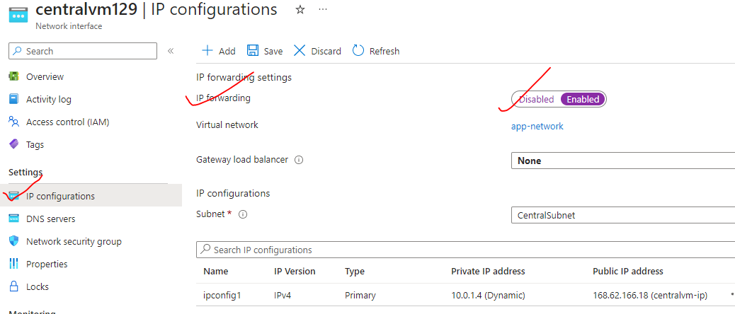

ENABLE EVENT FORWARDING ON CENTRAL VM

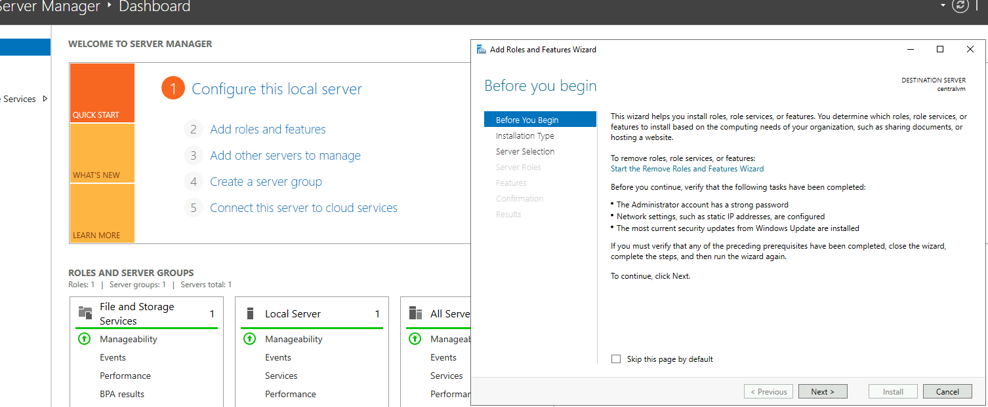

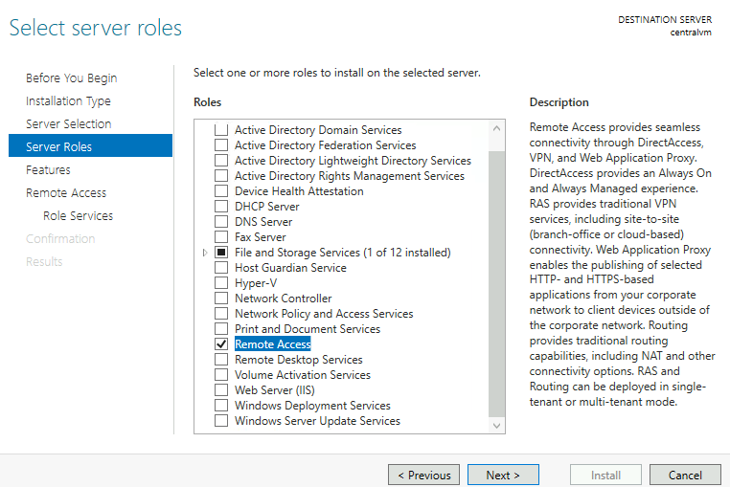

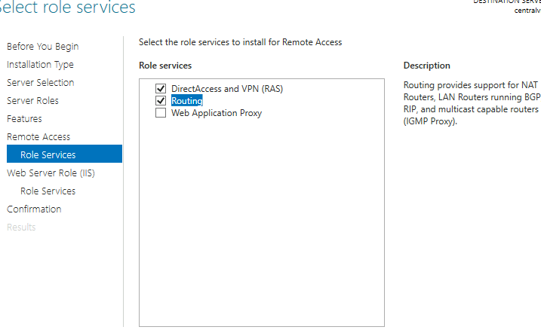

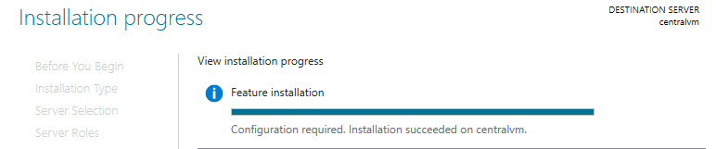

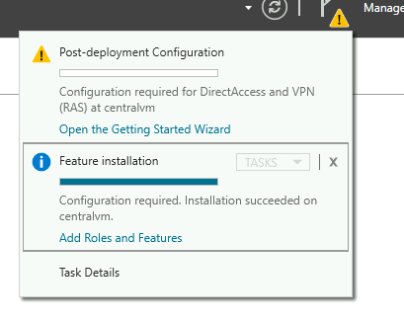

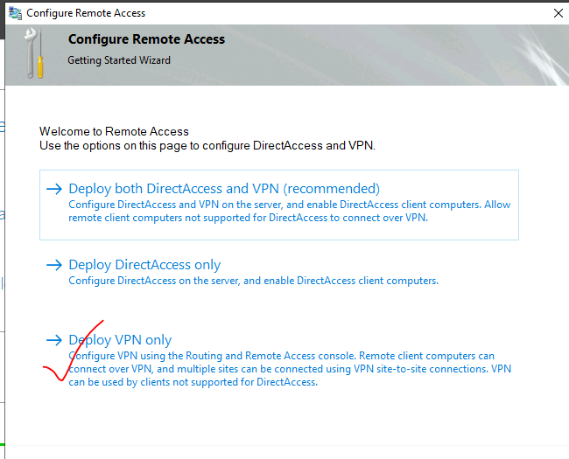

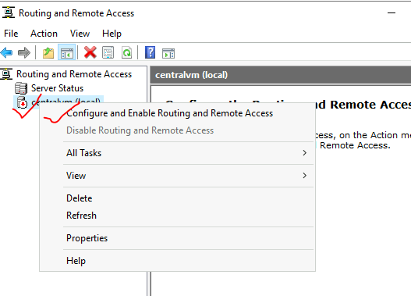

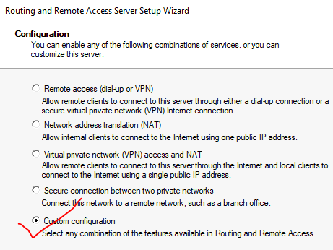

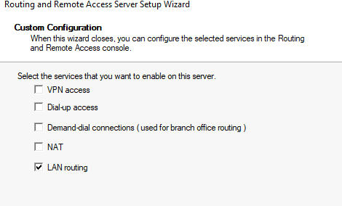

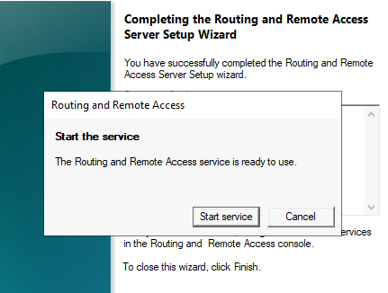

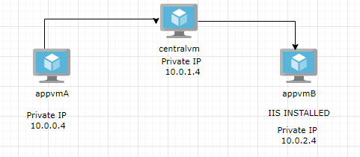

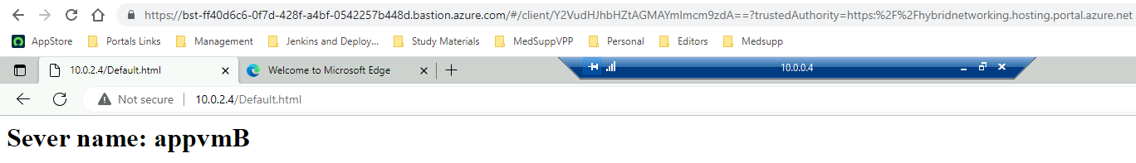

## NETWORK WATCHER

## AZURE BASTION SERVICE

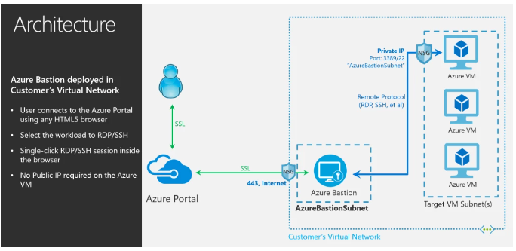

* Azure Bastion is a fully managed platform as a service (PaaS) offering provided by Microsoft Azure.
* **It provides secure and seamless RDP (Remote Desktop Protocol) and SSH (Secure Shell) connectivity to virtual machines (VMs) within Azure virtual network – using the private IP address.**
* Azure Bastion acts as a jump server or a bastion host, allowing users to securely access their VMs through the Azure portal using a web browser. It eliminates the need to expose VMs directly to the public internet or manage complex network configurations.

KEY FEATURES AND BENEFITS OF AZURE BASTION INCLUDE:

* SECURE REMOTE ACCESS:
  + **Azure Bastion provides secure and encrypted RDP/SSH connectivity to VMs over the public internet**, reducing the attack surface area compared to traditional methods.
* NO PUBLIC IP REQUIRED:
  + With Azure Bastion, VMs do not require a public IP address.
  + Access to VMs is done through the Azure portal, which simplifies network security by reducing the exposure of VMs to the internet.
* SIMPLIFIED CONNECTIVITY:
  + Users can connect to VMs from the Azure portal without the need for additional client software or VPN configurations. It provides a seamless and user-friendly experience.
* BUILT-IN PROTECTION:
  + Azure Bastion is fully integrated with Azure Active Directory (Azure AD) and supports multi-factor authentication (MFA), providing an additional layer of security for remote access.
* AUDITING AND LOGGING:
  + Azure Bastion provides audit logs, which can be used for monitoring and tracking access to VMs. These logs can be integrated with Azure Monitor and other security monitoring tools.

**NOTE**:

* Azure Bastion is deployed within a virtual network (VNet) as a dedicated subnet(named as “***AzureBastionSubnet***”.). This subnet acts as a secure gateway for accessing VMs within that VNet.

### SETTING UP BASTION SERVICE

**CREATING A VM WITHOUT PUBLIC IP**

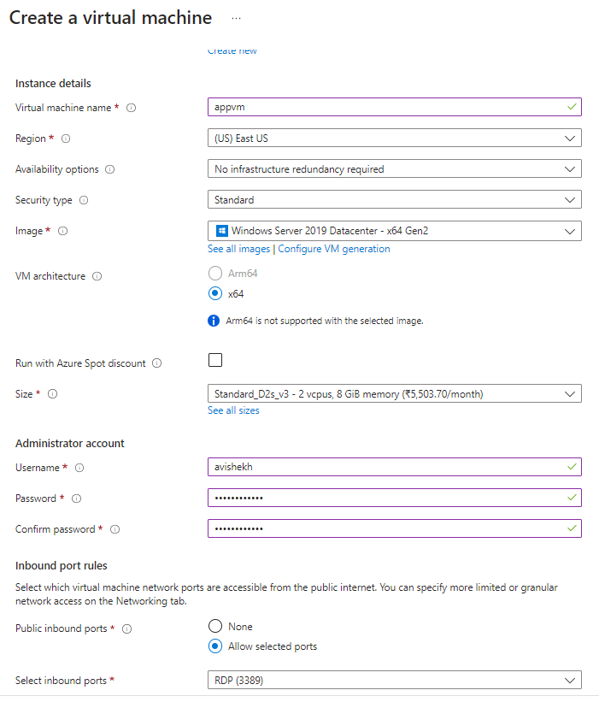

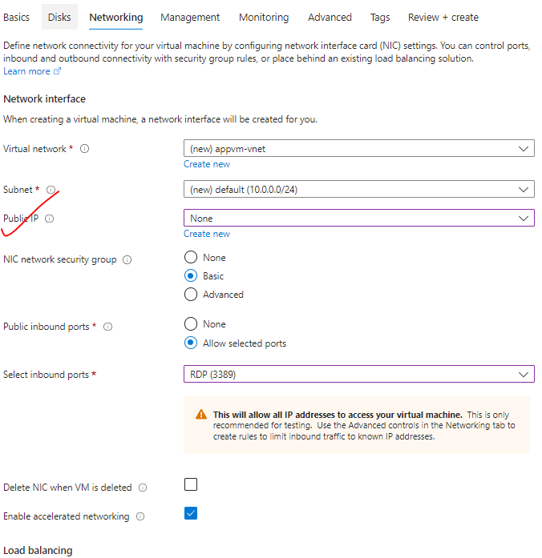

**CREATING SUBNET WITH NAME “AzureBastionSubnet”**

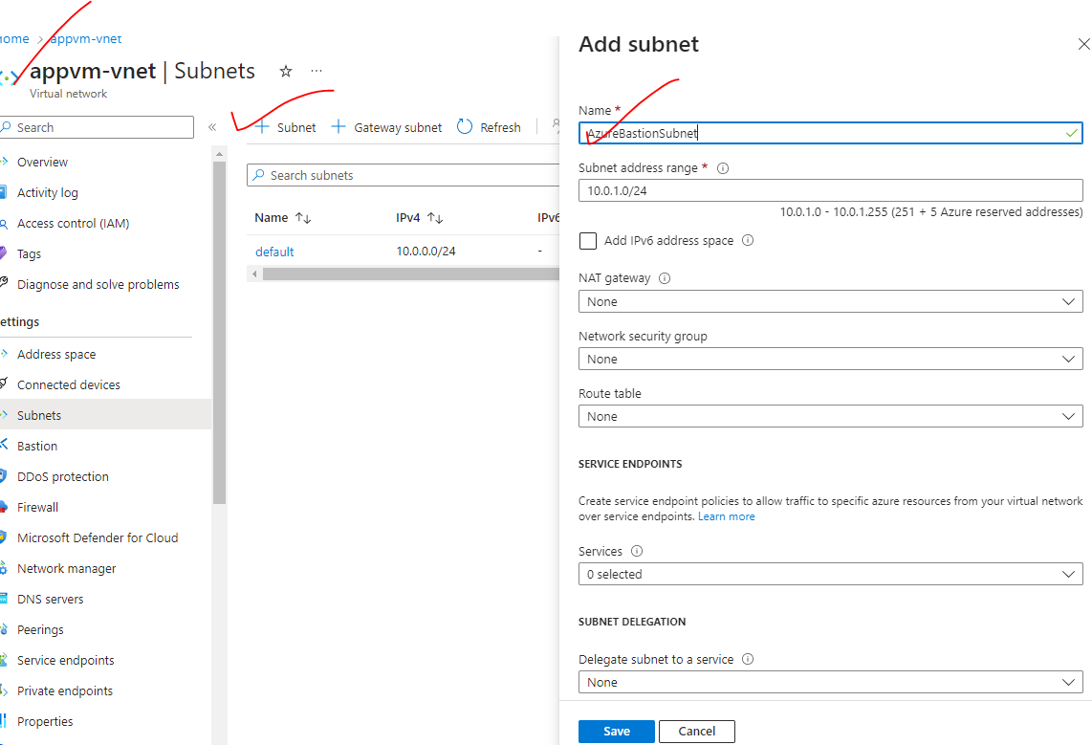

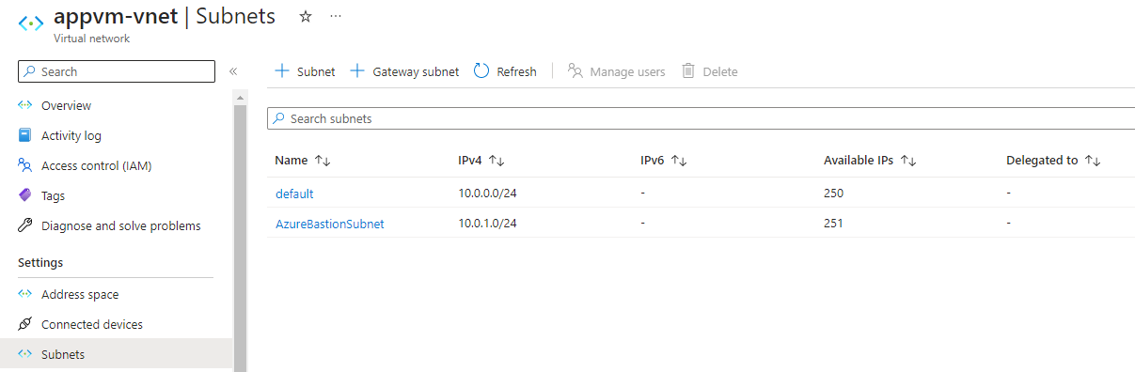

**CONFIGURE THE BASTION SERVICE**

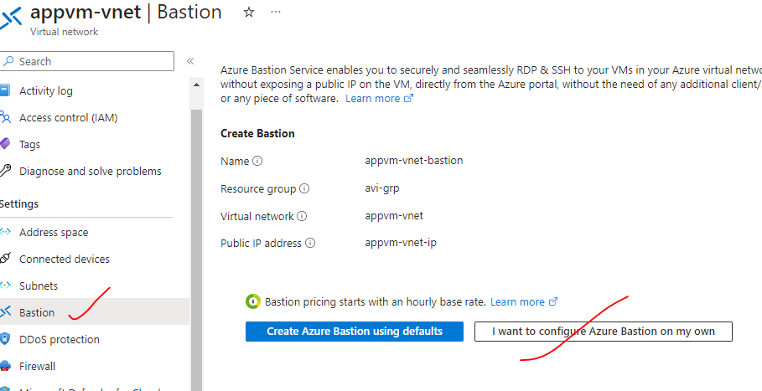

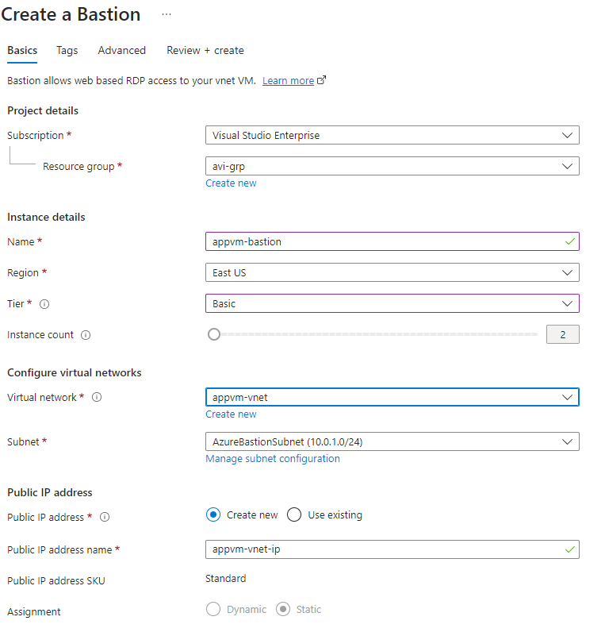

LOGIN INTO VM USING BASTION

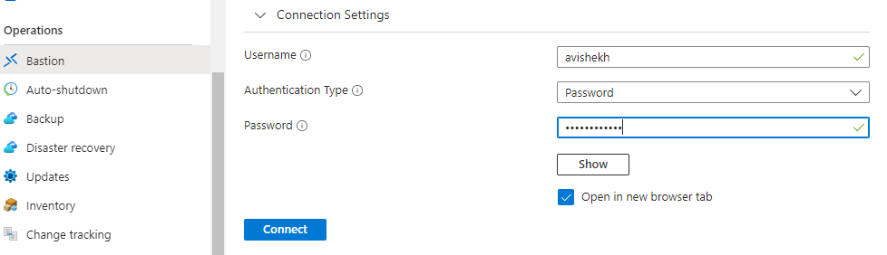

## EXPRESS ROUTE

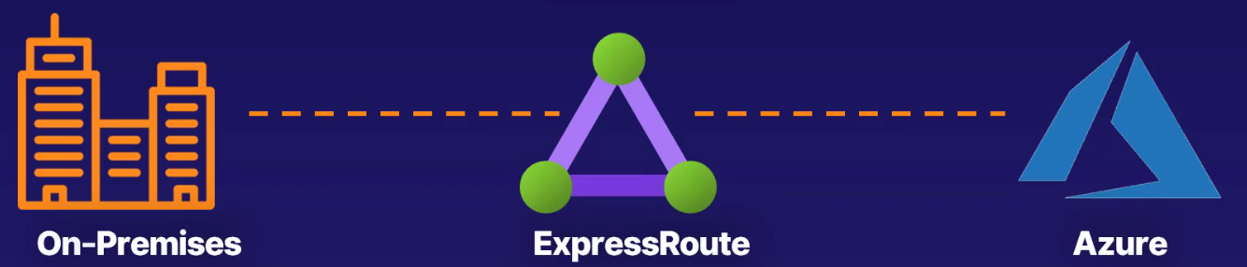

* ExpressRoute is a service provided by Microsoft Azure that **allows us to establish a private and dedicated network connection between the on-premises network and Azure.**
* It provides a more reliable, faster, and more secure connection compared to traditional internet-based connections.

KEY POINTS

* PRIVATE CONNECTION:
  + **ExpressRoute enables us to establish a private and dedicated connection to Azure, bypassing the public internet.**
  + **This ensures better security, lower latency, and higher bandwidth for the data transfer.**
* SERVICE PROVIDERS:
  + ExpressRoute can be provisioned through various service providers globally.
  + These service providers offer connectivity options, such as MPLS or Ethernet, to connect the on-premises network to Azure.
* DEDICATED CIRCUITS:
  + ExpressRoute circuits provide the physical connectivity between the on-premises network and Azure.
  + They can be provisioned with different bandwidth options, ranging from 50 Mbps up to 100 Gbps, depending on our requirements.
* HYBRID SCENARIOS
  + **ExpressRoute is commonly used for hybrid cloud scenarios, where we want to extend the on-premises network to Azure and have seamless connectivity between your resources.**

## AZURE FIREWALL

### WHAT IS A FIREWALL

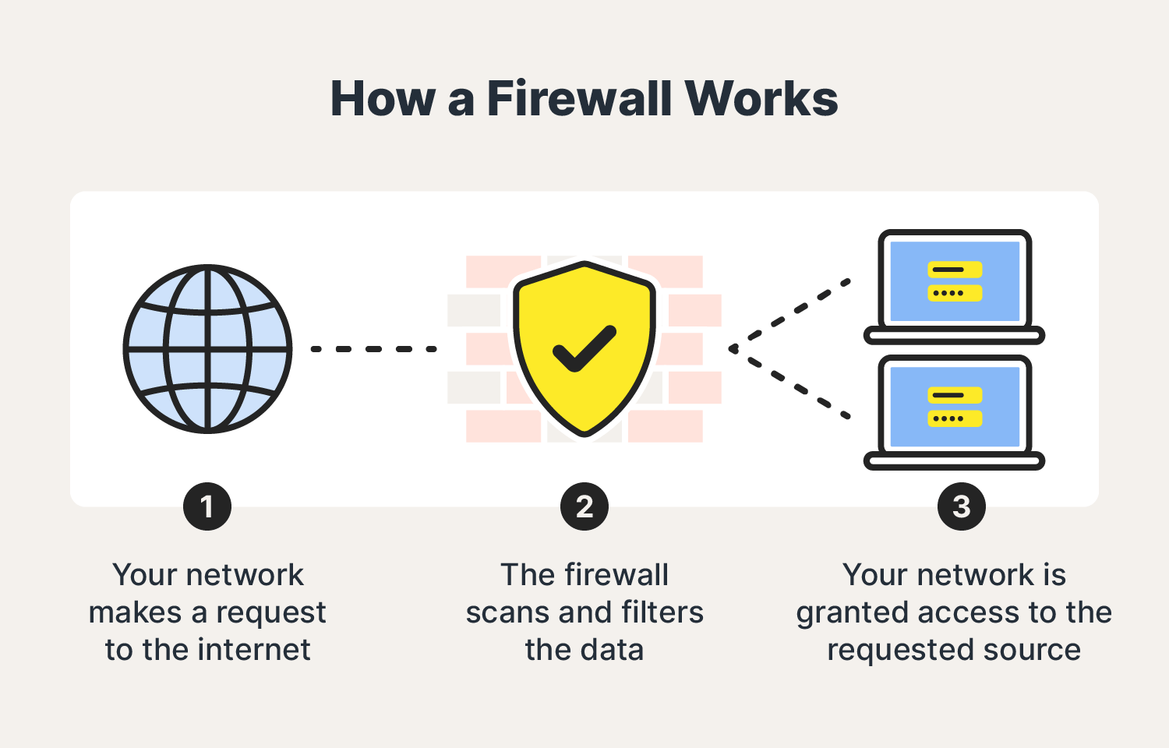

* **A firewall is a network security device or software that acts as a barrier between a trusted internal network and an untrusted external network, such as the internet.**
* Its primary function is to monitor and control incoming and outgoing network traffic based on predetermined security rules. It helps protect a network by inspecting each packet of data that enters or leaves the network and making decisions on whether to allow or block the traffic based on the configured rules. These rules can be defined by administrators to enforce security policies and protect against unauthorized access, threats, and malicious activities.

### AZURE FIREWALL SERVICE

* Azure Firewall is a cloud-based network security service offered by Microsoft Azure. It provides centralized, highly scalable, and fully stateful firewall capabilities for securing Azure Virtual Network (VNet) resources.

KEY FEATURES AND FUNCTIONALITIES OF AZURE FIREWALL

* NETWORK SECURITY:
  + Azure Firewall acts as a network-based, layer 3 and 4 firewall, allowing us to define and enforce network security policies for Azure VNets.
  + It provides protection against unauthorized access, threats, and malicious activities.
* APPLICATION-LEVEL FILTERING:
  + Azure Firewall supports application-level filtering, allowing us to define rules based on specific applications and protocols, such as HTTP, HTTPS, SQL, and more.
  + This allows granular control over network traffic and enhances security for applications running in Azure.
* FULLY STATEFUL FIREWALL:
  + Azure Firewall maintains the state of network connections, which means it can intelligently allow or deny traffic based on the context of the connection. This ensures that only legitimate and authorized traffic is allowed through.
* HIGH AVAILABILITY:
  + Azure Firewall is a highly available service that is automatically scaled and distributed across multiple Azure regions, providing redundancy, and ensuring continuous protection for VNets.
* INTEGRATION WITH AZURE SERVICES:
  + Azure Firewall seamlessly integrates with other Azure services, such as ***Azure Monitor, Azure Log Analytics, and Azure Sentinel****,* allowing us to monitor and gain insights into network traffic, security events, and logs.
* SECURE CONNECTIVITY:
  + Azure Firewall supports features like outbound network address translation (NAT) and integration with Azure Virtual Network Gateway, enabling secure connectivity between on-premises networks and Azure VNets.
* CENTRALIZED MANAGEMENT AND POLICY ENFORCEMENT:
  + With Azure Firewall, we can centrally manage and enforce network security policies across multiple VNets using Azure Firewall Manager.
  + This provides a unified view and simplifies management of firewall rules and configurations.

#### DEPLOYING AZURE FIREWALL SERVICE

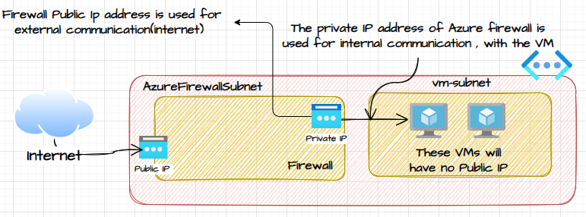

1. Create a VNET
2. Provision a VM in the VNET without a public IP address.
3. Note: The Azure Firewall service requires its own dedicated subnet names as “***AzureFirewallSubnet***”

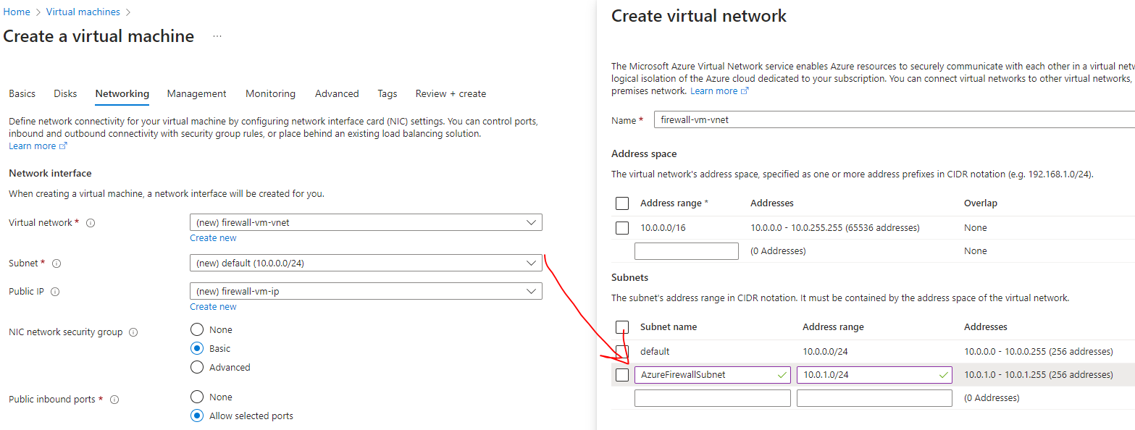

##### CREATING A FIREWALL SERVICE

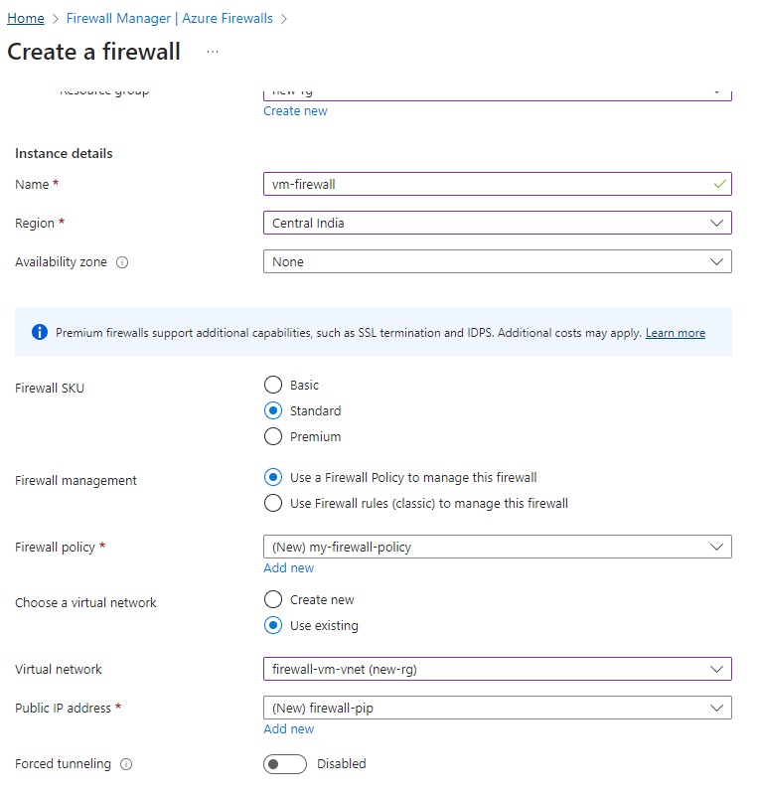

* In Firewall we create different rules. There are different ways of managing these rules.
  + - **FIREWALL POLICY –** *We will use firewall policy***.**
    - **CLASSIC RULE**
* **Azure Firewall will have its own private IP address which will be used for internal communication between the Azure VMs and the firewall itself.**
* Since the firewall look at traffic that is flowing from internal network onto the internet and vice versa – hence it has been assigned a public IP address. This exposes its interface onto the internet itself.

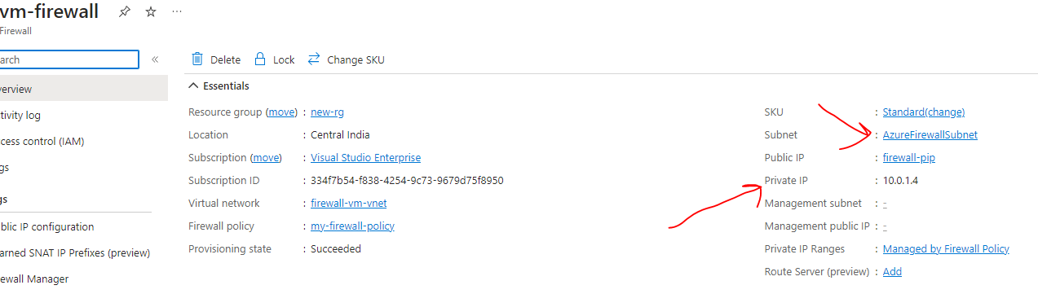

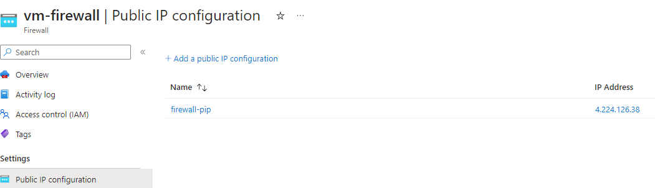

##### SETTING UP FILEWALL POLICIES

AZURE FIREWALL SUPPORTS MULTIPLE POLICY TYPES TO DEFINE AND ENFORCE NETWORK SECURITY RULES.

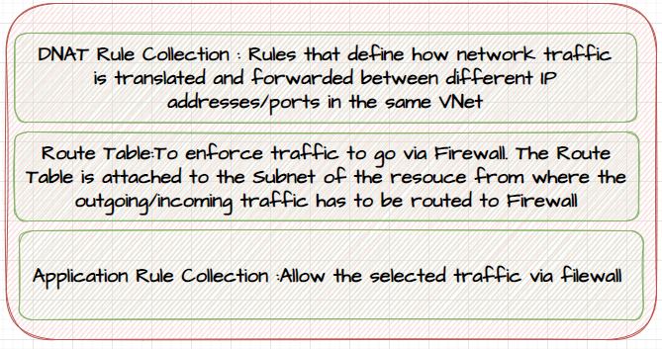

1. NETWORK RULE COLLECTION
   1. Network rule collections allow us to define rules based on source and destination IP addresses, ports, and protocols.
   2. We can create rules to allow or deny traffic between specific IP addresses or ranges.
   3. Network rule collections operate at the transport layer (Layer 4) of the network stack.
2. APPLICATION RULE COLLECTION
   1. Application rule collections enable us to control traffic based on specific applications and protocols.
   2. We can define rules to allow or deny traffic for applications like HTTP, HTTPS, SQL, FTP, and more.
   3. Application rule collections operate at the application layer (Layer 7) of the network stack.
3. NAT RULE COLLECTION

* NAT (Network Address Translation) rule collection is a set of rules that define how network traffic is translated and forwarded between different IP addresses and ports.
* NAT rule collections are used to control inbound and outbound traffic flow for resources deployed in virtual networks.
* Azure Firewall uses a stateful NAT implementation, which means that it keeps track of the state of network connections and automatically translates and forwards traffic accordingly. This allows for more efficient and secure network communication.

**TASK OF NAT RULES**

* + PORT FORWARDING
    - We can map incoming traffic from a specific port to a different port on a resource within the virtual network.
    - This allows external clients to access services running on specific ports of our resources.
  + NETWORK ADDRESS TRANSLATION
    - We can translate the source IP address of outgoing traffic to a different IP address.
    - This can be useful when you want to hide the actual IP addresses of your resources from external clients.
  + DESTINATION NETWORK ADDRESS TRANSLATION
    - We can translate the destination IP address of incoming traffic to a different IP address.
    - vThis can be used to redirect incoming traffic to a different resource within the virtual network.

1. DNS RULE COLLECTION
   1. DNS rule collections allow us to control DNS resolution for the virtual networks.
   2. We can define rules to allow or deny DNS queries based on DNS domain suffixes or specific DNS servers. DNS rule collections operate at the DNS layer.

###### CONFIGURING NAT RULES COLLECTION

* Click on the *Firewall Policy 🡪 DNAT Rules 🡪 Add Rule Collection*. DNAT rules are used for Network Address Translation.

EXAMPLES - 1

1. *Let’s say we have a web application deployed in the VM- which has only private IP. We can access the web application using the Public IP address of the Azure Firewall.*
2. ***The NAT Rules translates the public IP of firewall to the private IP of the VM***

EXAMPLES - 2

1. *On the similar note – we can RDP to the Azure VMs that are part of the Azure virtual network via the Azure Firewall public IP. Here also the NAT Rules translates the public IP of firewall to the private IP of the VM*

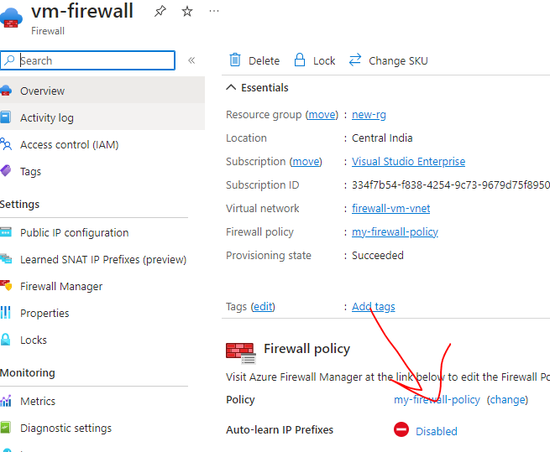

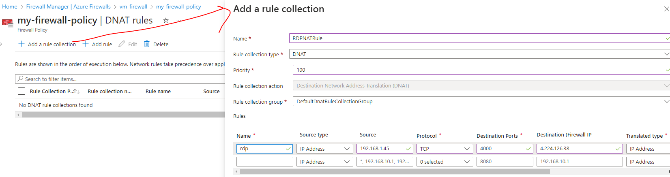

NAT RULE CONFIGURATION

1. For **Name**, enter *rdp*.
2. For **Priority**, enter *200*.
3. For **Rule collection group**, select **DefaultDnatRuleCollectionGroup**.
4. Under **Rules**, for **Name**, enter *rdp-nat*.
5. For **Source type**, select **IP address**.(it can be public IP address of another VM from where we want to do RDP)
6. For **Source**, enter *\**.
7. For **Protocol**, select **TCP**.
8. For **Destination Ports**, enter ***4000***.
9. For **Destination Type**, select **IP Address**.
10. For **Destination**, enter the **firewall public IP address**.
11. For **Translated address**, enter **the private IP address of the VM**.
12. For **Translated port**, enter ***3389***.
13. Select **Add**.

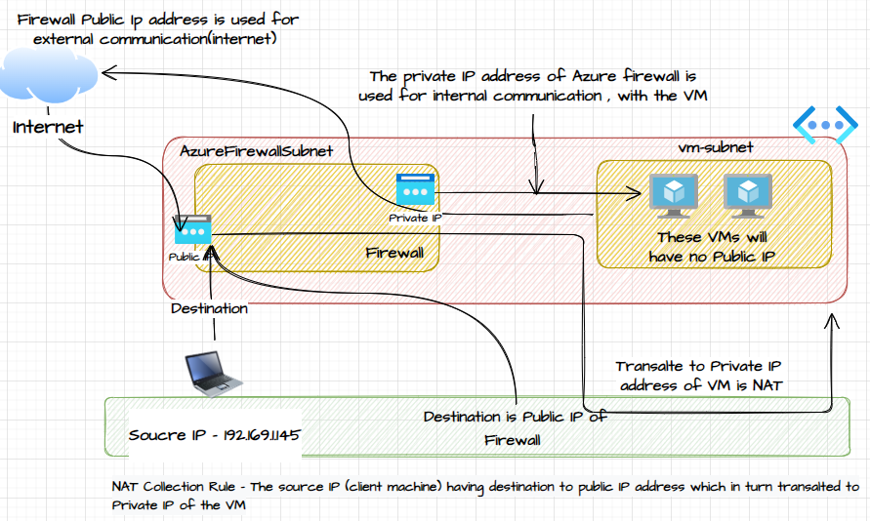

|  |  |
| --- | --- |
|  |  |

###### CONFIGURING ROUTE TABLE (SUBNET LEVEL)

* ***The purpose of a firewall is to ensure that it restricts the outbound and inbound traffic to VM in the VNET.***
* ***To enforce such restrictions- so that traffic can be routed via Firewall*** 
  + STEP 1: CREATE A ROUTE TABLE
  + STEP 2: ATTACH THE ROUTE TABLE TO THE SUBNET OF THE RESOURCES, WHOSE TRAFFIC HAS TO BE VIA FIREWALL

CREATING A ROUTE TABLE

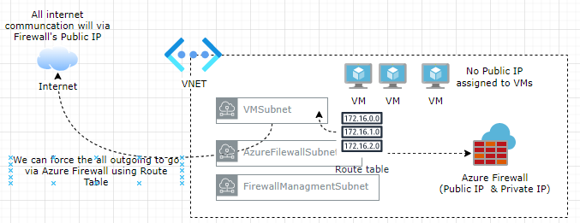

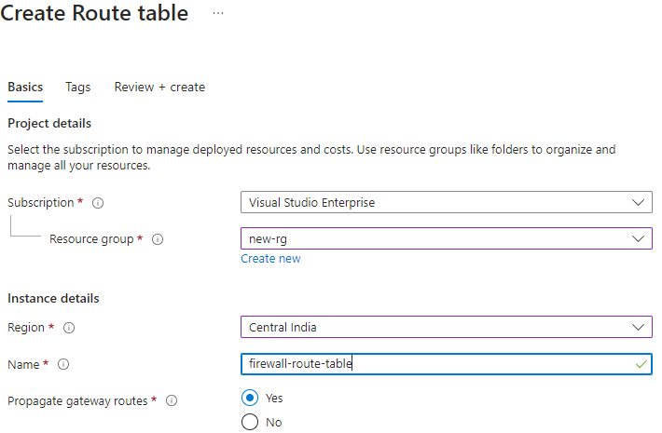

ASSOCIATE THE ROUTE TABLE WITH THE SUBNET

* The route table are configured on VM Subnet level.

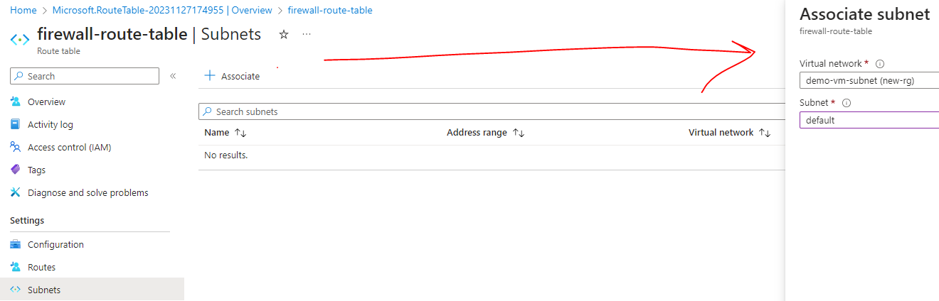

ADD ROUTES TO THE ROUTE TABLE

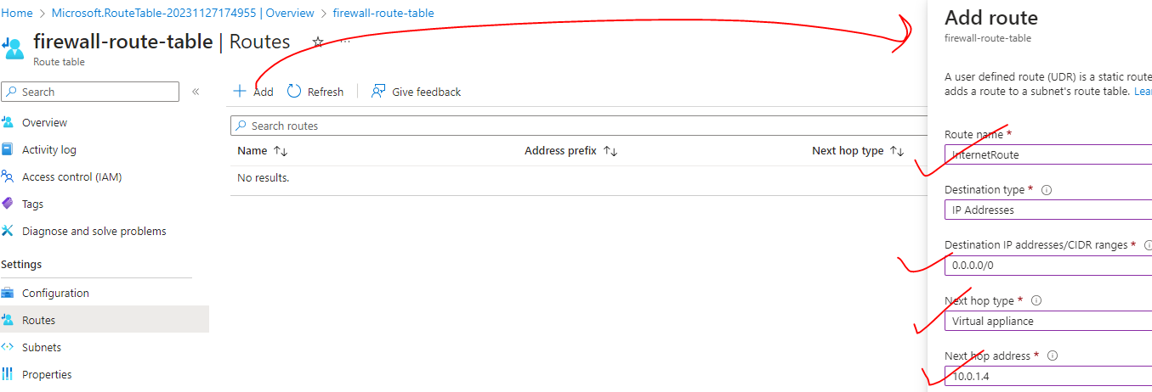

* **The route table will say that for any traffic that is destined for the internet needs to flow via the Azure Firewall resource**. In the above configuration we are saying that if there is any traffic that is destined for the internet, then the next hop type needs to be a virtual appliance. The next hop address is it needs to be the **private IP address** of the Azure Firewall.
* *Note:* 
  + *While adding routes- for the internet, the address prefix is normally 0.0.0.0/0.*
  + *Next hop address – This is the private IP address of the Azure Firewall*
* ***This route says - any outbound traffic(internet) needs to be routed onto the Azure Firewall on its private IP address.***

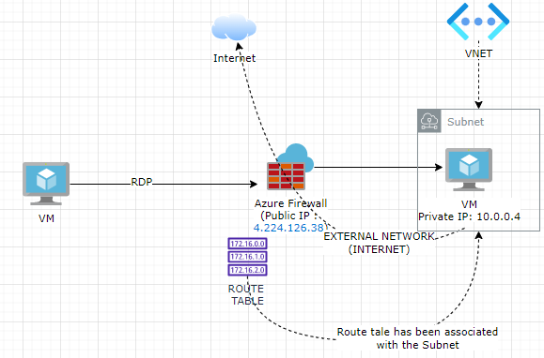

###### CONFIGURING APPLICATION RULES

* Application rules are organized into application rule collections. An application rule collection consists of one or more rules that define the traffic allowed or denied based on specific applications or protocols.
* **For example, let's say that we want to allow outgoing traffic- to a fully qualified domain name (e.g., microsoft.com) - we can do that with the help of application-based rules.**

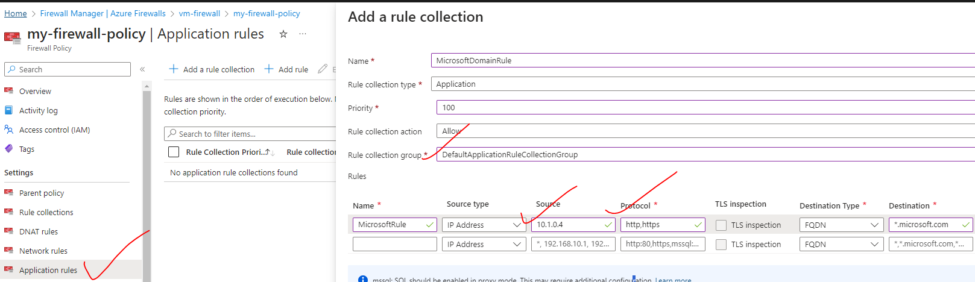

|  |  |
| --- | --- |
| **Source** | *This is the private IP of the VM where we want to allow the FQDN (*[*https://www.microsoft.com/*](https://www.microsoft.com/)*)* |
| **Protocol** | Allowed Protocol (http and https) – Comma Separated |
| **Destination Type** | FQDN – Fully Qualified Domain Name |
| **Destination** | Allowed Domain (Comma Separated) |

## AZURE TRAFFIC MANAGER

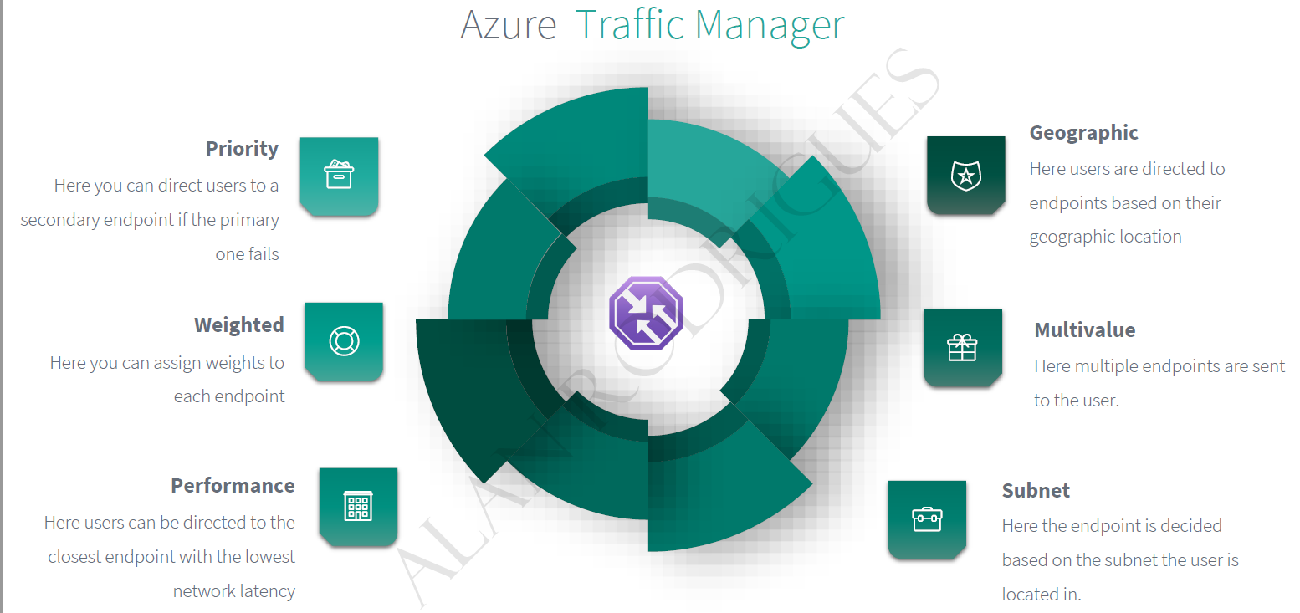

* **Traffic Manager a DNS based traffic load balancer.**
* Enables the distribution of incoming traffic across multiple endpoints or services based on various traffic-routing methods. It helps improve the availability, responsiveness, and scalability of applications by directing traffic to the most suitable endpoint based on factors such as geographic proximity, endpoint health, or priority. The endpoint needs to be public endpoint that can be hosted inside or outside Azure

**KEY FEATURES AND BENEFITS OF AZURE TRAFFIC MANAGER:**

* LOAD BALANCING
  + Traffic Manager uses load balancing algorithms to distribute incoming traffic across multiple endpoints.
  + It can balance traffic based on performance (round-robin, weighted round-robin, performance-based), geographic proximity (geographic routing), or endpoint health (availability).
* HIGH AVAILABILITY
  + By distributing traffic across multiple endpoints, Traffic Manager helps improve the availability and reliability of applications. If an endpoint becomes unavailable, Traffic Manager automatically redirects traffic to other healthy endpoints, minimizing downtime.
* GEOGRAPHIC ROUTING
  + Traffic Manager can route traffic to the endpoint that is geographically closest to the client, improving performance and reducing latency for global applications. This is especially useful for multi-region deployments or when serving content to users in different geographic locations.
* TRAFFIC FAILOVER
  + Traffic Manager can be configured to perform automatic failover in case an endpoint becomes unavailable. It can monitor the health of endpoints and redirect traffic to alternative endpoints if necessary, ensuring continuous availability.
* TRAFFIC MONITORING AND INSIGHTS
  + Traffic Manager provides monitoring and reporting capabilities, allowing you to track the performance and availability of your endpoints.
  + It provides insights into endpoint health, traffic patterns, and latency, helping you optimize your application's performance.
* **The Azure load balancer and Application gateways are regional (i.e.it can manage the resources in a given region), but a traffic manager is a global service**. Hence when we deploy a traffic manager profile- we don’t to specify a region for the deployment of the resource.

### TRAFFIC MANAGER ENPOINTS

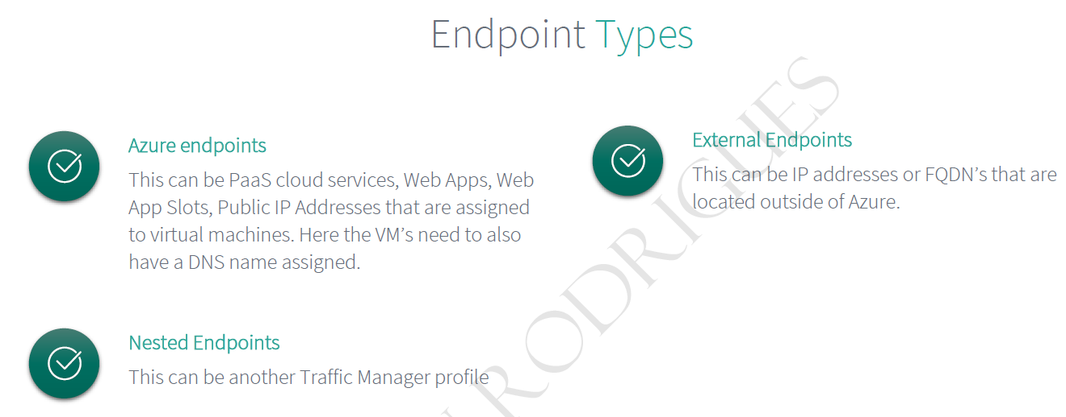

### AZURE TRAFFIC MANAGER ROUTING METHODS

Azure Traffic Manager supports **six traffic-routing methods to determine how to route network traffic to the various service endpoints.** For any profile, Traffic Manager applies the traffic-routing method associated to it to each DNS query it receives. The traffic-routing method determines which endpoint is returned in the DNS response.

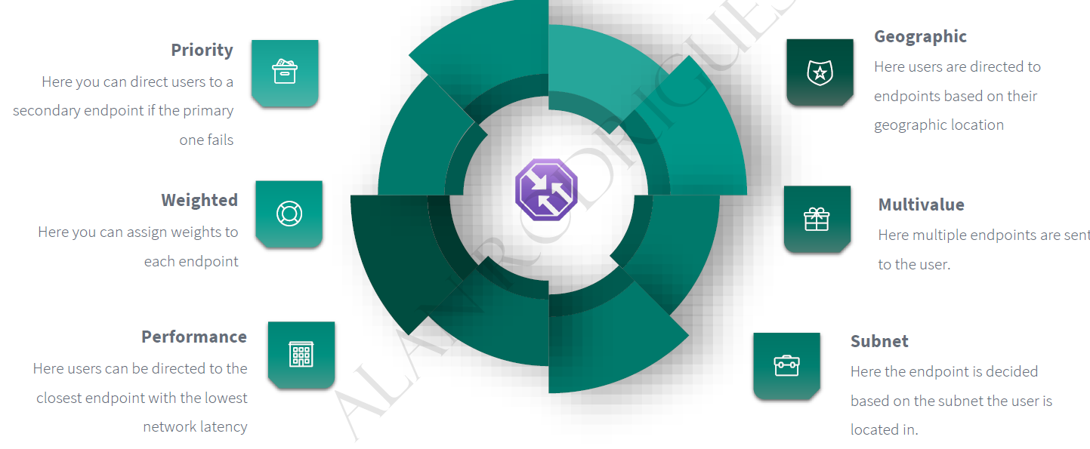

### PRIORITY ROUTING METHOD

|  |  |
| --- | --- |
|  | * The Traffic Manager Priority routing method is one of the traffic-routing methods offered by Azure Traffic Manager. * It allows us to define a prioritized list of endpoints, and incoming traffic is directed to the highest priority endpoint that is available and healthy. |

#### SETTING UP PRIORITY ROUTING METHOD

STEP 1*: SET UP VMs IN DIFFRENT REGION (it can be in same region too. Since TM is a global service, it can manage resources in any region)*

STEP 2:

* + INSTALL IIS on both VMs – These are the VM where the traffic will be directed.
  + Add a DNS names to the VMs – as traffic manager does DNS based routing.

|  |  |
| --- | --- |
|  | * STEP 3: Search for **Traffic Manager Profile 🡪 Create** * *As it is a global service, hence we don’t need to mention the region of the Traffic Manager Profile (unlike Load Balancer and App Gateway).* |
|  | * Add a DNS names to the VMs * Go to VM Overview 🡪 Click on Public IP address🡪 DNS name label |

STEP 4: Add the VMs to the traffic Manager endpoint.

|  |  |  |
| --- | --- | --- |
|  | **The priority will define – which public IP(VM public IP) will be a Primary End point** | |
| * When the priority is higher means when users access the traffic manager end point, all of the users will be directed to this VM. Only when the primary VM goes down that user will be directed the secondary VM the IBM or the endpoint, this is like a fallback mechanism. * After adding the endpoint – make sure Monitor Status is “Online” | |

STEP 4: Now the VMs can be accessed via Traffic Manager DNS name.

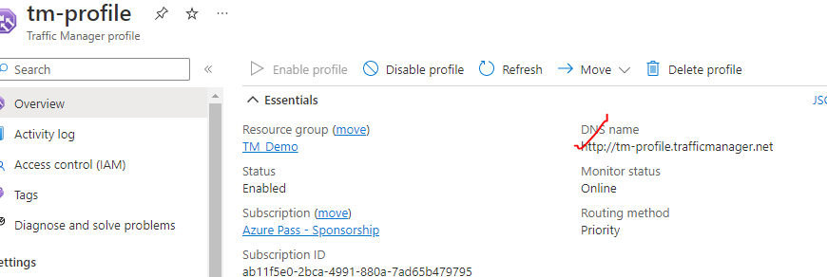

|  |  |
| --- | --- |
|  | * Note – In the above example – if we stop the primary VM – the request will be then route to secondary endpoint * PROBING INTERVAL (In sec.) – The time interval in which probing will happen * TOLERATED NUMBER OF FAILURES – After this TM will consider it as unhealthy resource * PROBE TIMEOUT - |
|  | |

|  |  |
| --- | --- |
|  | TO UPDATE THE EXISTING ROUTING METHOD   * Delete the existing endpoints. * Go to configuration of TM 🡪 Routing Method 🡪 Save. * Add the endpoints again. |

### PERFORMANCE ROUTING METHOD

* In performance routing method – it routes the traffic to the location which is closest to user location.

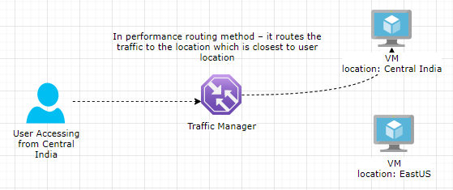

### GEOGRAPIC ROUTING METHOD

1. ***In Geographic routing method the end point depending upon the location the DNS query originates from (it depends upon user’s location).***
2. This is different from the performance routing method. In the performance routing method, the traffic manager looks for a resource which takes less time in terms of latency. That is the endpoint that will be returned to the user.

#### SETTING GEOGRAPIC ROUTING METHOD

Step 1: Create 2 VMs in two different Region

Step 2: Configure the traffic manager endpoint 🡪 Select the region which will serve the request which is coming from the same region

|  |  |
| --- | --- |
|  |  |

### PERFORMANCE VERSUS GEOGRAPHICAL ROUTING

|  |  |  |
| --- | --- | --- |
| Routing Method | Performance Routing | Geographic Routing |
| Description | Distributes traffic to endpoints based on performance metrics like latency, responsiveness, or capacity. | Routes traffic to the endpoint geographically closest to the client, based on their IP address. |
| Endpoint Selection | Based on performance metrics (e.g., lowest latency, highest capacity). | Based on geographic proximity between the client and the endpoint's location. |
| Use Case | Ideal for scenarios where performance is critical, such as minimizing latency or maximizing capacity. | Suitable for scenarios where proximity to the user is important, like serving content specific to different regions. |
| Endpoint Monitoring | Monitors endpoint health and performance using health checks and performance measurements. | Monitors endpoint health and availability using health checks. |
| Failover | Automatically fails over to the next available endpoint with the next best performance metric in case of an endpoint failure. | Automatically fails over to the next available endpoint in case of an endpoint failure. |
| DNS Resolution | Traffic Manager returns an IP address that corresponds to the endpoint with the best performance metric based on the client's location. | Traffic Manager returns an IP address that corresponds to the endpoint geographically closest to the client's location. |
| Traffic Distribution | Traffic is distributed based on performance metrics, such as latency or capacity, ensuring optimal performance for end users. | Traffic is distributed based on geographic proximity, minimizing latency and improving user experience. |
| Configuration Complexity | Requires configuring performance metrics, setting up health checks, and assigning weights to endpoints based on performance. | Requires defining regions and associating endpoints with specific geographic locations. |
| Multi-region Support | Can span multiple regions and distribute traffic based on performance across regions. | Can route traffic to different regions based on geographic proximity. |
| Example Use Case | A global web application serving users worldwide, where low latency and high capacity are crucial. | Content delivery network (CDN) serving static assets to users in different regions, where proximity and reduced latency are important. |

### WEIGHTED ROUTING METHOD

|  |  |
| --- | --- |
|  | * In weighted routing method we weight each endpoint in the traffic manager profile * Let’s say if we 2 VM (endpoints)- which are weighted 50. The traffic to TM will be distributed across endpoint based on the weight assigned to endpoints. |

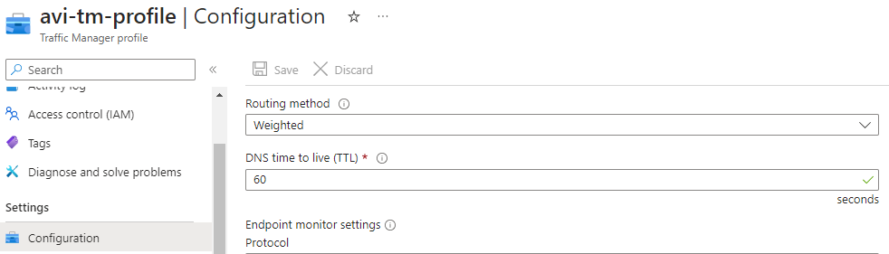

ADDING AN ENDPOINT BY WEIGHT

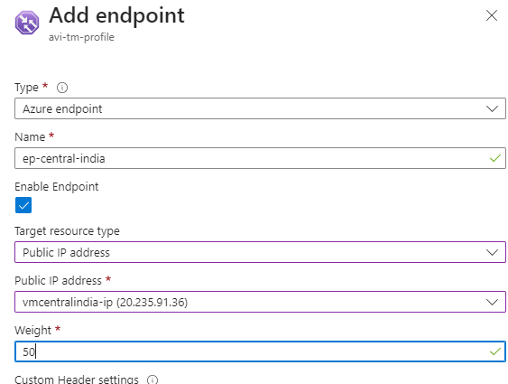

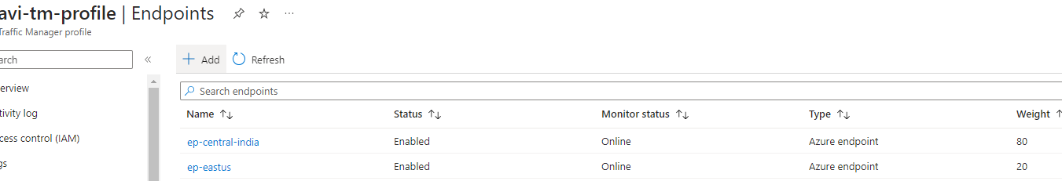

#### USE CASE OF WEIGHTED ROUTING METHOD – BLUE GREEN DEPLOYMENT

* Blue-Green deployment is a software release management strategy where two identical environments, known as the "Blue" and "Green" environments, are created. Traffic is initially directed to the Blue environment while the Green environment is updated and tested. Once the Green environment is validated, the traffic is switched from Blue to Green, making it the new active environment.

HERE'S HOW WE CAN ACHIEVE BLUE-GREEN DEPLOYMENTS WITH AZURE TRAFFIC MANAGER:

1. SET UP BLUE AND GREEN ENVIRONMENTS
   1. Create two identical environments, such as Azure Web Apps or Azure Virtual Machines, representing the blue and green environments.
2. DEPLOY AND TEST UPDATES ON THE GREEN ENVIRONMENT:
   1. Update and deploy your application changes to the Green environment. Perform thorough testing to ensure the new version is functioning correctly.
3. CONFIGURE TRAFFIC MANAGER PROFILES:
   1. Create an Azure Traffic Manager profile and configure it to distribute traffic between the Blue and Green environments.
   2. Use a load-balancing method like weighted or performance-based routing to control the traffic distribution.
4. ROUTE TRAFFIC TO THE BLUE ENVIRONMENT:
   1. Initially, direct all incoming traffic to the Blue environment by setting a higher weight or higher priority for the Blue endpoint in the Traffic Manager profile.
5. SWITCH TRAFFIC TO THE GREEN ENVIRONMENT:
   1. Once the Green environment is validated, update the Traffic Manager profile to route traffic to the Green environment. This can be done by adjusting the weights or priorities to favor the Green environment.

### SUBNET ROUTING METHOD

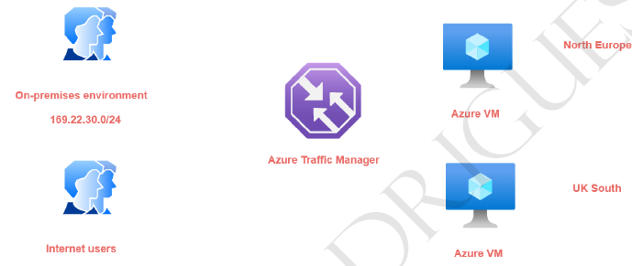

|  |  |
| --- | --- |
|  | * In this routing method – we map a specific set of end-user IP address range to specific endpoint. For example, if we want to direct the traffic from on premises environment- having a particular IP address range to an endpoint and all other internet users onto another endpoint. * **The subnet routing methods - looks at the IP address range of the clients that are connecting to the traffic manager and then they be directed onto the end point.** * If we want to create a default endpoint that is created- so that if the other end points don't * match the subnet range then the default end point will serve the request. For default endpoint the subnet routing settings is kept empty. * Hence – let’s say if the user hit the TM DNS and if the user’s IP does not fall in the range of Subnet routing setting – it will fallback to the default route |

### MULTIVALUED ROUTING METHOD

### TRAFFIC MANAGER – NESTED ROUTING

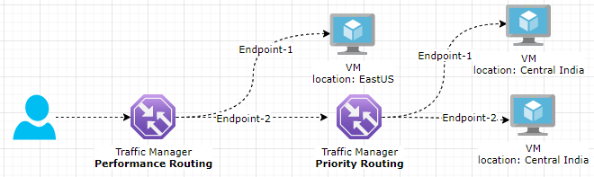

IN NESTED ENDPOINTS, WE CAN COMBINE TRAFFIC MANAGER PROFILES TOGETHER

#### EXAMPLE

TRAFFIC MANAGER 1 : PRIORITY ROUTING

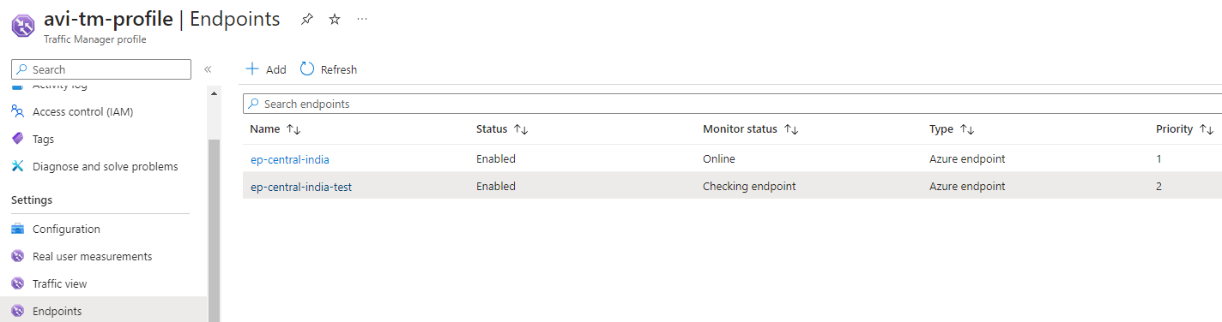

TRAFFIC MANAGER 2 : PERFORMANCE ROUTING

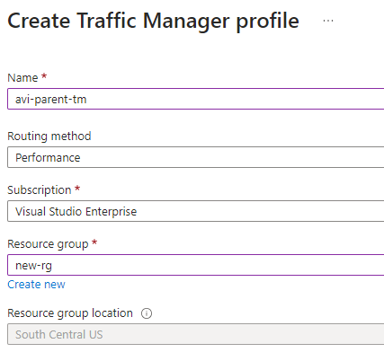

ADDING TRAFFIC MANAGER ENDPOINT TO ANOTHER TRAFFIC MANAGER

|  |  |
| --- | --- |
| **Type** | Nested Endpoint |
| **Name** | Name of Endpoint |
| **Target Resource** | Child Traffic Manager |
| **Location** | Location of the Resources routed by child Traffic manager |
| **Minimum Child Endpoints** | * Minimum number of child endpoints that should be part of the traffic manager profile. * Since we using the priority routing method in child profile, which has two endpoints- hence we have to ensure that that profile has a minimum of two child endpoints. |

1 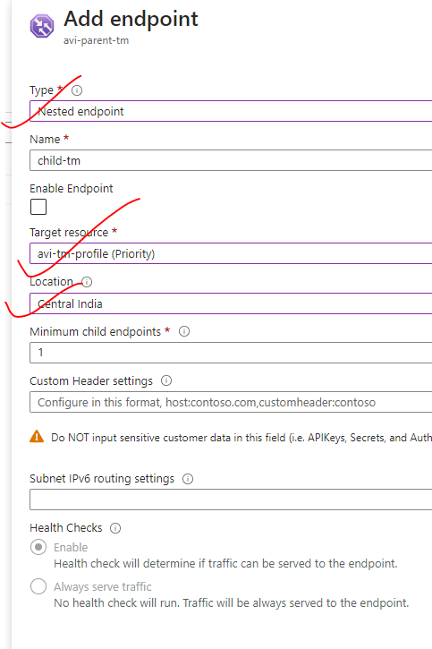

## AZURE FRONTDOOR

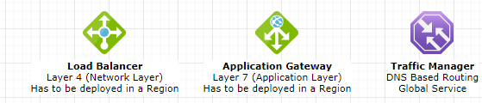

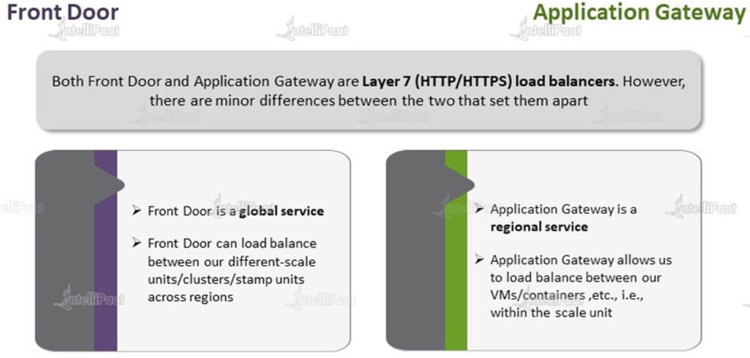

* Azure Front Door is a cloud-based global content delivery network (CDN) service. It acts as an intelligent entry point for the web applications, serving as a global load balancer, SSL/TLS termination point, and application accelerator.
* Azure Front Door service is a global service where the delivery of content is done via **point of presence servers**.

FRONT DOOR SET UP- AN EXAMPLE

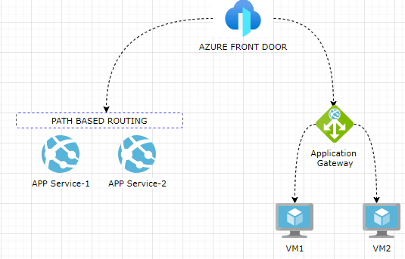

* From Front door we can direct the traffic to web apps using a path-based routing service or direct the traffic to an Azure application gateway. The Azure Application Gateway can then internally route traffic onto Azure VMs. Hence- there are different combinations that are possible when it comes on to the Azure front door service.
* DELIVERY OF CONTENT
  + When a user makes a request to Azure front door service. By default, the Azure front door service will point the request to an end point, which is closest, having the least latency (like performance routing method of Azure traffic manager)

|  |  |
| --- | --- |
| Cloudflare Error 1200 - How to resolve | * A Point of Presence (PoP) server is a physical or virtual server that is strategically located within a network or content delivery network (CDN) at a specific geographical location. * The purpose of a PoP server is to improve the performance and availability of services for end-users in that region. |

KEY FEATURES AND BENEFITS OF AZURE FRONT DOOR:

* GLOBAL LOAD BALANCING:
  + Azure Front Door distributes incoming traffic across multiple backend endpoints, improving availability and providing high performance for users worldwide.
* TRAFFIC ROUTING:
  + Front Door supports intelligent routing based on various criteria, such as geographic location, latency, and HTTP characteristics.
  + This ensures that user requests are directed to the most optimal backend endpoint.
* SSL/TLS TERMINATION:
  + Front Door terminates SSL/TLS connections at the edge, reducing the load on backend servers and improving performance.
* WEB APPLICATION FIREWALL (WAF):
  + Azure Front Door includes built-in WAF capabilities to protect against common web vulnerabilities and threats, helping to secure your applications.
* CACHING AND ACCELERATION:
  + Front Door caches static content at the edge locations, reducing the load on backend servers and improving response times for users.
* HIGH AVAILABILITY:
  + Azure Front Door is designed for high availability, with automatic failover and health monitoring of backend endpoints.
* ANALYTICS AND MONITORING:
  + Front Door provides detailed analytics and monitoring capabilities, allowing you to gain insights into your application's performance and user behavior.
* INTEGRATION WITH AZURE SERVICES:
  + Front Door seamlessly integrates with other Azure services such as Azure CDN, Azure App Service, and Azure Kubernetes Service (AKS), enabling you to build end-to-end application delivery solutions.

### SETTING UP FRONTDOOR

1. Search for service 🡪 Front Door and CDN Profiles

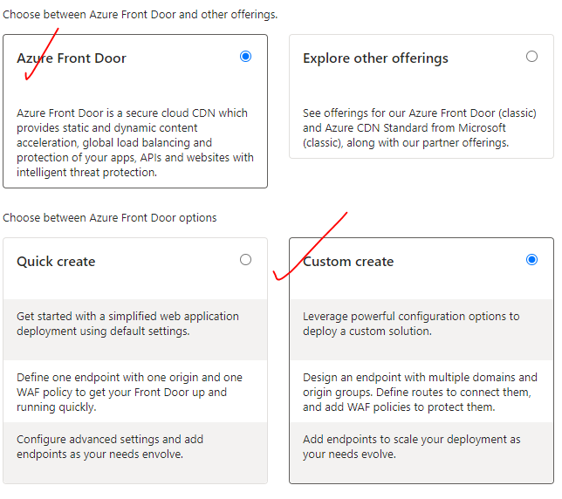

1. NO REGION FOR FD IS REQUIRED AS IT IS A GLOBAL SERVICE

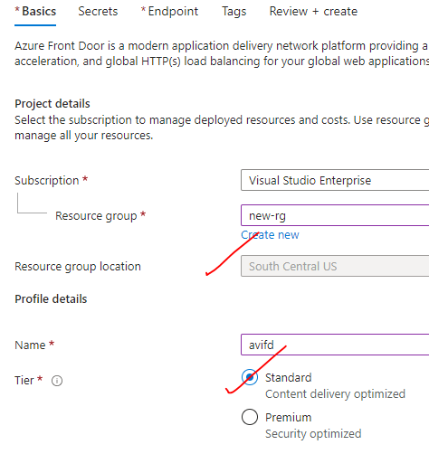

1. ADD ENDPOINTS

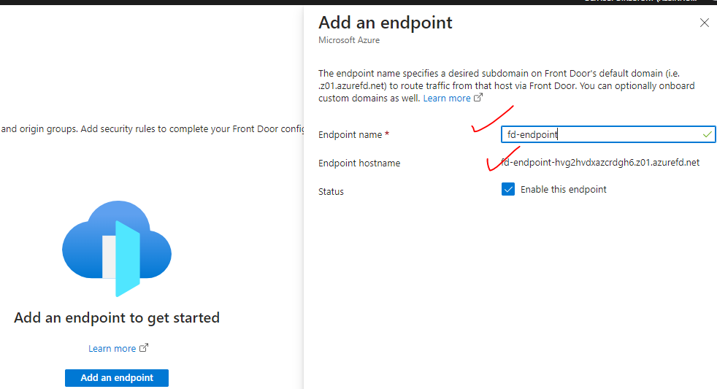

1. ADD ROUTES AND WAF POLICIES

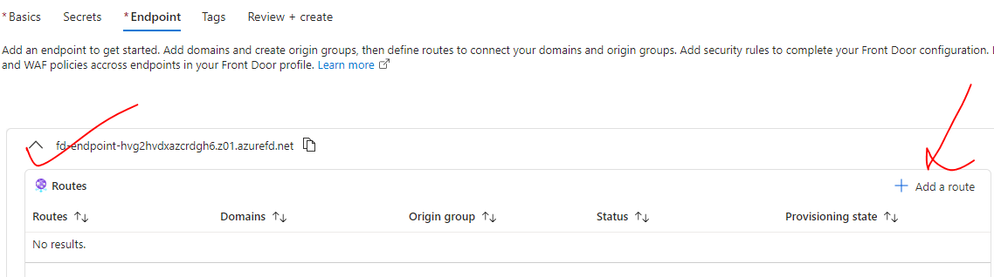

* Add Origin group 🡪 Give the origin group name.
* + Add the origin.

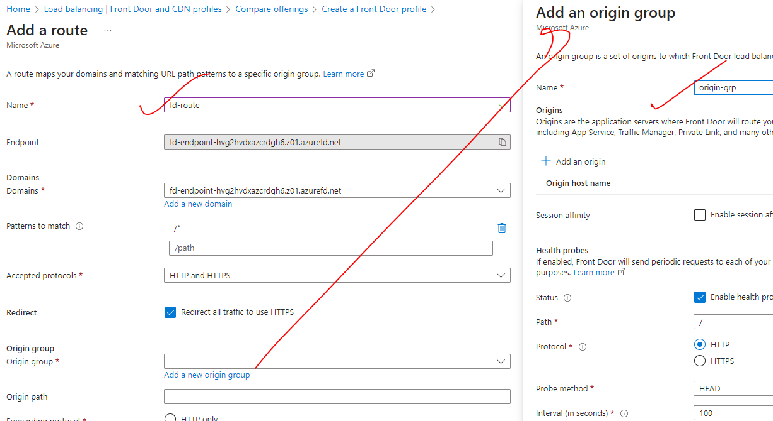

* Add all VMs in the origin group

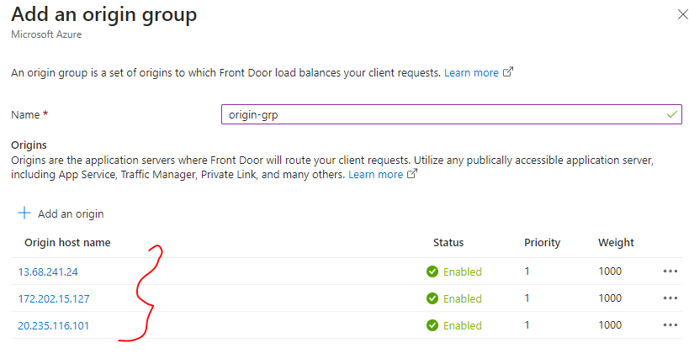

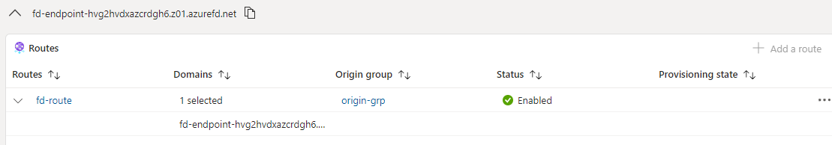

Frontend Endpoint: <http://fd-endpoint-hvg2hvdxazcrdgh6.z01.azurefd.net/> 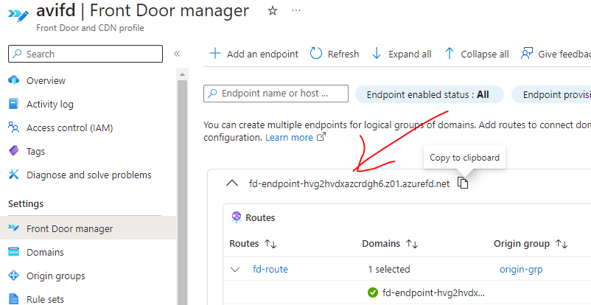

## DOMAIN NAME SYSTEM

* The Domain Name System (DNS) is a hierarchical decentralized naming system **that translates human-readable domain names (such as example.com) into IP addresses (such as 192.0.2.1)** that computers can understand.
* It serves as a directory for the internet, allowing users to access websites, send emails, and perform various network activities using easy-to-remember domain names instead of having to remember the numerical IP addresses associated with each website or service.
* **The DNS system works by maintaining a distributed database of domain name records and utilizing DNS servers to resolve domain names to their corresponding IP addresses.**

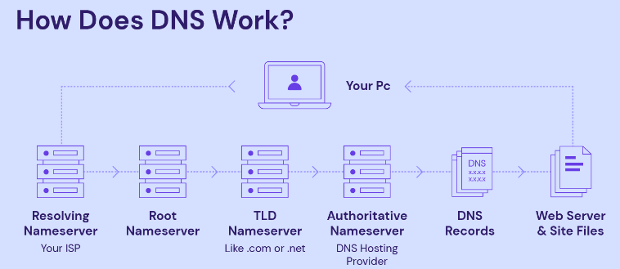

* **A DNS record is an IP address that matches the**[**fully-qualified domain name**](https://www.hostinger.in/tutorials/fqdn)**.**
* When we enter the domain name into the web browser’s address bar i.e. when we submit a **DNS request**. First, the computer will search its hosts file and cache. The **hosts file**is a plain text file that maps hostnames to IP addresses in an operating system, while the **cache**is temporary data stored by a hardware or software component**.**
* Matching IP addresses for the DNS service are commonly found in your [browser cache](https://www.hostinger.in/tutorials/clear-browser-cache) or internet service provider (ISP) cache.
* If the computer can’t find a matching IP address in your hosts file or cache, it will submit our DNS query or request to the DNS servers.

DNS RESOLVER

* The **DNS resolver**or **recursive resolver** acts as the primary intermediary between a computer and other DNS servers. Its purpose is to forward a request to other domain name system servers and then send it back once fulfilled.
* When the DNS resolver receives a request, it will first search its cache to find a matching IP address for the domain name. If said IP address found, the request sent to the DNS servers ends here, and you will immediately see the site you want to visit.
* However, if no match is found in its cache, the DNS resolver will send the request to the next DNS server – the root nameserver.

ROOT NAMESERVER

* The **root nameserver**or **root DNS server**is at the top of the DNS hierarchy. Think of it as a bank of reference.
* It doesn’t keep the information you’re looking for, which is the IP address to match the domain name – but it gives directions to where it can be found.
* Once the root nameserver receives a request from the recursive DNS resolver, it will identify the [top-level domain](https://www.hostinger.in/tutorials/what-is-tld) of the domain name. Then, it will tell the recursive resolver to go to the correct TLD nameserver.

TLD NAMESERVER

1. The **TLD nameserver**is a DNS server function that is responsible for storing and managing information about domain names that use a specific **top-level domain (TLD)**. A TLD is the far end of a domain name, such as [.com](https://www.hostinger.in/tld/com-domain)**,**[.org](https://www.hostinger.in/tld/org-domain)**,**[.online](https://www.hostinger.in/tld/online-domain), and [.net](https://www.hostinger.in/tld/net-domain).
2. If your query is to find the IP address of **hostinger.com**, the root nameserver will redirect the DNS recursive resolver to the **.com**TLD nameserver. Next, the TLD nameserver will inform the resolver about the location of the matching IP address at a specific authoritative nameserver.

AUTHORITATIVE NAMESERVER

1. The **authoritative nameserver**or **authoritative DNS server**is the final authority in the DNS resolution process. It stores all information related to the domain name you want to visit, including its IP address. The recursive resolver will obtain the IP address and send it back to your computer, directing you to the site.
2. Finally, the domain name system resolver performs**DNS caching**, storing IP addresses collected from authoritative nameservers as temporary data. In other words, DNS caching makes it so that the next time you want to visit the same site, it will simply send back the IP address match obtained before.

### DOMAIN REGISTRAR

The role of an internet domain registrar in the DNS working **is to facilitate the registration and management of domain names.**

Functions and responsibilities of a domain registrar in the DNS process:

* DOMAIN REGISTRATION
  + Domain registrars allow individuals and organizations to register domain names for their websites.
  + They act as intermediaries between the registrant (the person or entity registering the domain) and the domain registry, which maintains the central database of domain names for a specific top-level domain (TLD).
* DNS CONFIGURATION:
  + After registering a domain, the registrar provides tools and interfaces for managing DNS settings. This includes configuring DNS records such as A records, CNAME records, MX records, and others. These records define how the domain name maps to its associated IP addresses, email servers, and other services.
* NAME SERVER MANAGEMENT:
  + Domain registrars allow users to specify the authoritative nameservers for their domain.
  + **These nameservers are responsible for providing the DNS resolution for the domain**. The registrar facilitates the configuration and management of these nameservers, allowing users to point their domain to the appropriate DNS infrastructure.

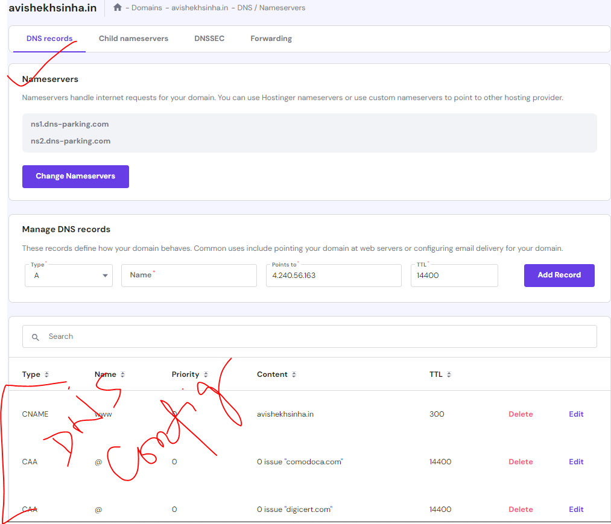

### ZONE FILE

* Zone file record sets are a collection of DNS resource records (RRs) that define the DNS settings for a specific domain or zone. These records are stored in a zone file, which is a text file that contains the authoritative DNS information for a domain. Here are some common types of DNS resource record sets that can be found in a zone file:

1. A Record (Address Record):
   1. This record maps a domain name to an IPv4 address.
   2. It specifies the IP address where the domain or subdomain should be resolved to.  
      Example:  
      example.com. IN A 192.0.2.1

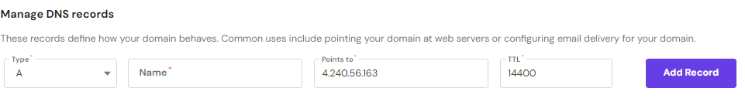

1. AAAA Record (IPv6 Address Record): AAAA record maps a domain name to an IPv6 address.  
   Example:  
   example.com. IN AAAA 2001:db8::1
2. CNAME Record (Canonical Name Record):
   1. This record creates an alias or canonical name for a domain. It allows multiple domain names to resolve to the same IP address.  
      Example:  
      [www.example.com](http://www.example.com/). IN CNAME example.com.
3. MX Record (Mail Exchanger Record):
   1. This record specifies the mail servers responsible for handling incoming email for a domain.  
      Example:  
      example.com. IN MX 10 mail.example.com.
4. NS Record (Name Server Record):
   1. The NS record specifies the authoritative nameservers for a domain.  
      Example:  
      example.com. IN NS ns1.example.com.  
      example.com. IN NS ns2.example.com.

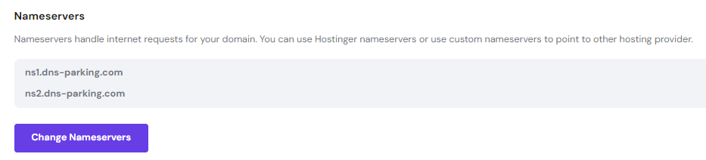

NOTE

* <https://www.digwebinterface.com/> - This utility will resolve the IP to DNS and Vice versa

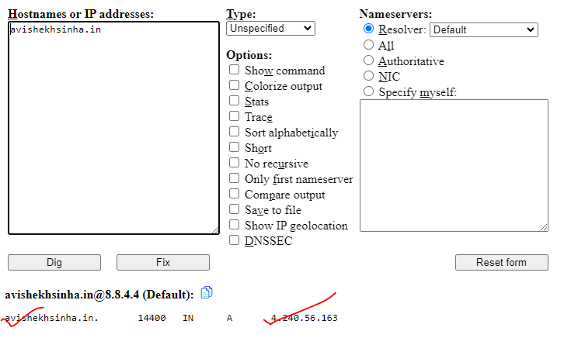

### ROUTING A DOMAIN TO A VM

* STEP 1: CREATE A VM and INSTALL ISS
* **STEP 2: ADD “A” RECORD WITH THE PUBLIC IP IN DOMAIN PROVIDER’S ZONE FILE**

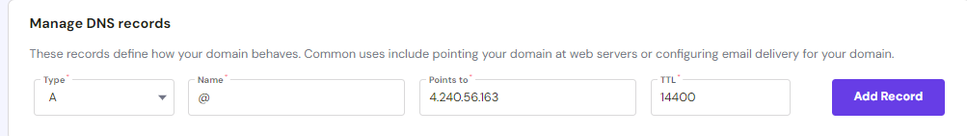



* STEP 3: If the domain is registered (e.g avishekhsinha.in) – then we can be able to see IIS homepage with this domain.

## AZURE PUBLIC DNS

### AZURE DNS ZONE SERVICE

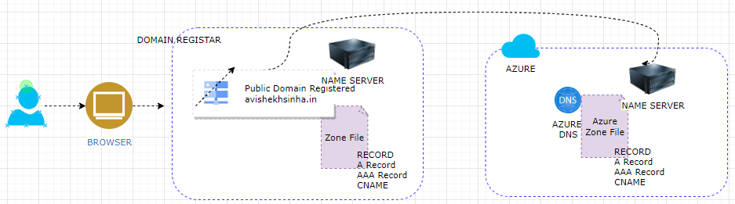

* To resolve the domains - the domain registars refer the zone file. We need to manage the zone file (DNS Records) in registrars (e.g., GoDaddy) server itself.
* **Using Azure DNS Zone Service - we can manage the zone file for the domain in Azure itself instead of creating the records in the external domain provider.**

#### CREATE AZURE DNS ZONE SERVICE

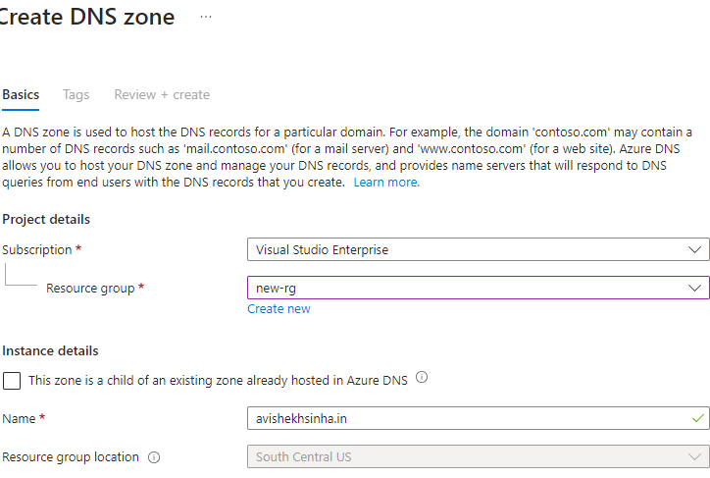

* The name of the DNS zone will be the public domain

#### UPDATE THE A RECORD SET

* Add the “Record Set” in the DNS Zone 🡪 Add the “A” record

|  |  |
| --- | --- |
| **Name** | * If blank the it can we access by : avishekhsinha.in * If name is provided e.g ”azure” – we can access it using : azure.avishekhsinha.in |
| **IP address** | Public IP address of the VM |

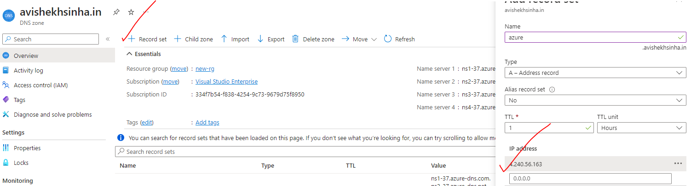

#### UPDATE THE NAMESERVER

* As the “A “record in place in Azure. Now we need to configure the external domain provider so that whenever any request comes to ”avishekhsinha.in” - don't resolve it yourself 🡪 go onto the Azure platform to resolve it.
* Go to the Domain Provider configuration and update Nameservers. We need update the name server with the name-servers in DNS zone service.

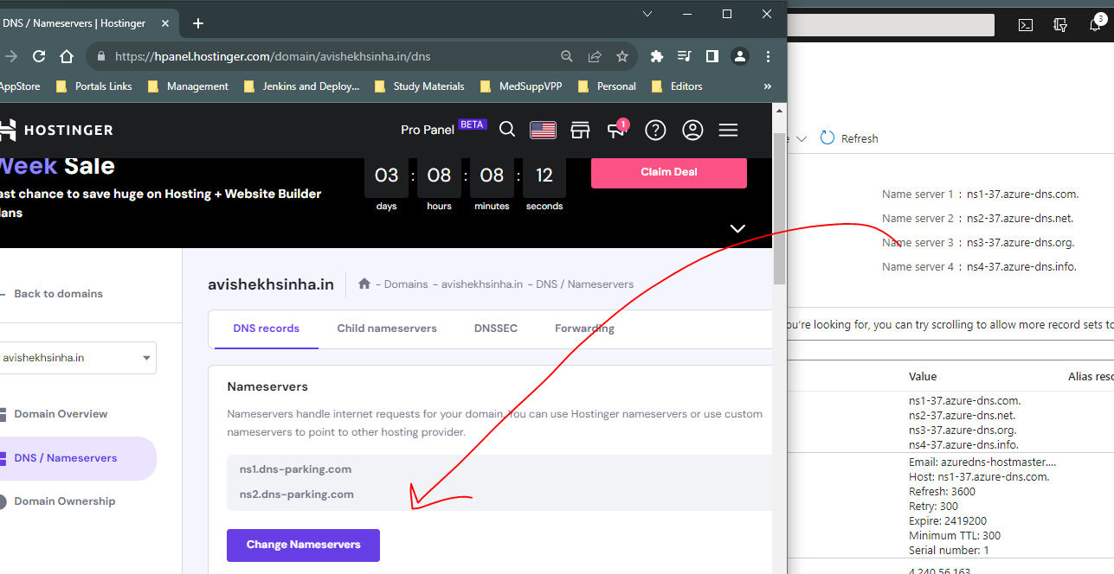

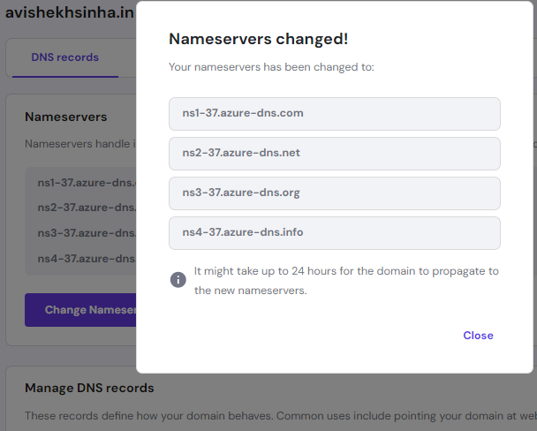

* The IIS page can be accessed using *azure.avishekhsinha.in*

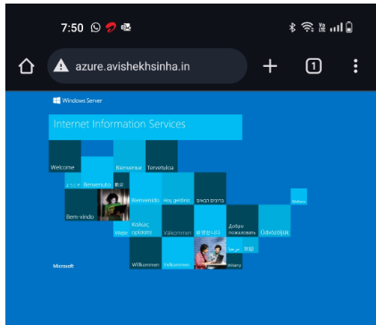

## LOCAL DNS

* In Azure, we can set up a local DNS server within a virtual machine (VM) to handle name resolution for the virtual network. **This is often referred to as a "local DNS resolver" or "custom DNS server" within Azure.**

## AZURE PRIVATE DNS

* **Azure Private DNS is a feature provided by Microsoft Azure that allows us to securely resolve domain names within the Azure virtual network (VNet) without the need for public IP addresses or internet connectivity**.
* It provides name resolution between resources within the VNet, including virtual machines, Azure services, and our own custom domain names.
* With Azure Private DNS, we can create DNS zones and records that are only visible and resolvable within the VNet.
* This helps to keep the DNS traffic within your private network, improving security and reducing the risk of DNS attacks. It also enables you to use your own domain names for resources within Azure, making it easier to manage and identify your resources.

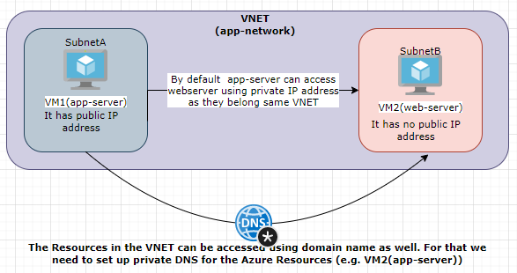

### SETUP THE VMs

* Step 1: Create a VM (app-server) – using the we will access the another resources using domain name. The VM will have a public address so tat we can log-in to the VM
* Step 2: Create another VM (web-server)
  + This VM will have no private IP addesss
  + We will install IIS in the VM
  + This VM will have only private IP address
  + This VM will be accessed via DNS

### CREATE PRIVATE DNS ZONE

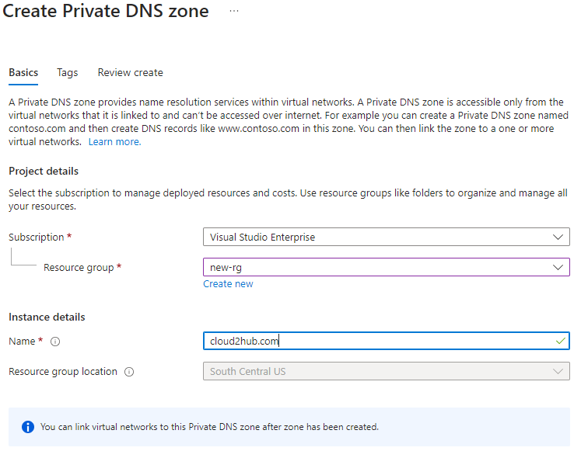

* The Private DNS does not have any nameserver details

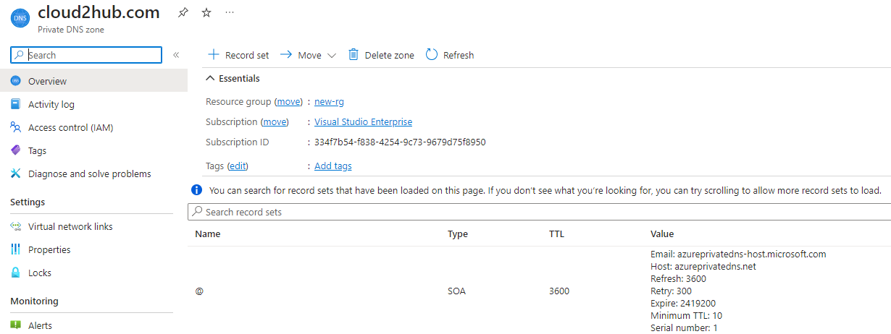

### LINK THE VNET WITH PRIVATE DNS ZONE

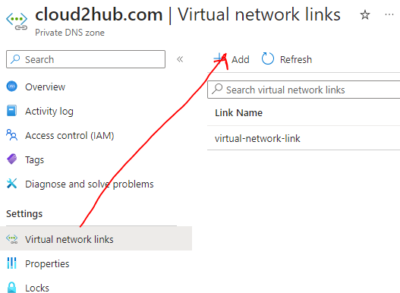

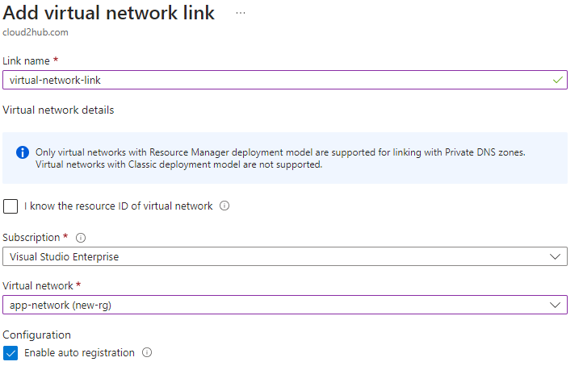

### ACCESS THE RESOURCE

* To access the resources we can use following format : <resource-name>.<domain-name>. Example : <http://web-server.cloud2hub.com/>

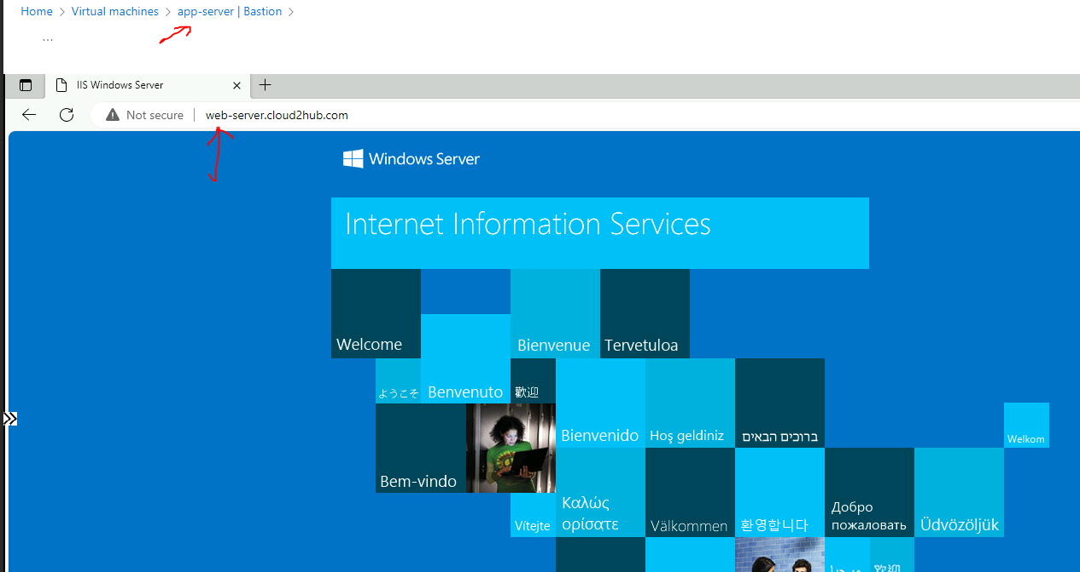

* We can configure the Private IP address in the record set to access directly using domain name e,g. <http://cloud2hub.com/>

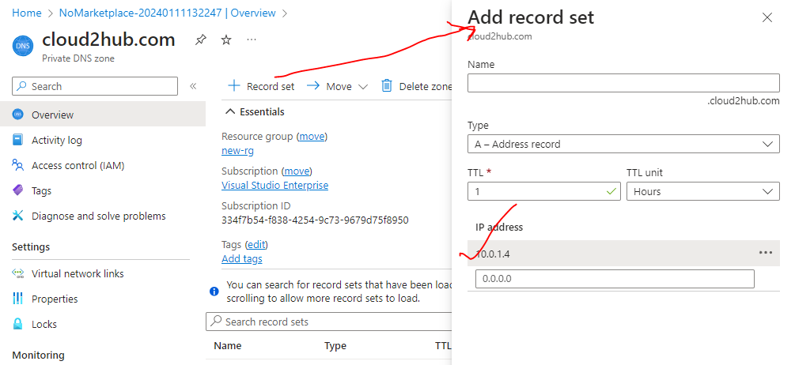

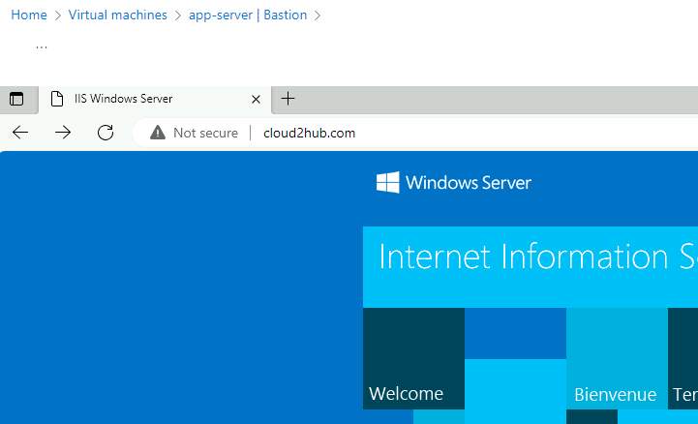

## AZURE DNS – PEERED NETWORKS

* Azure Private DNS can be used in conjunction with Azure Virtual Network peering to enable name resolution across multiple virtual networks. When we peer two virtual networks, we establish a private connection between them, allowing resources in one network to communicate with resources in the other network using private IP addresses.
* By enabling Azure Private DNS on peered virtual networks, we can resolve domain names across both networks without the need for public IP addresses or internet connectivity. This allows us to create a private DNS zone in one network and access it from the other network.

**TO SET UP AZURE PRIVATE DNS WITH PEERED NETWORKS, YOU NEED TO PERFORM THE FOLLOWING STEPS:**

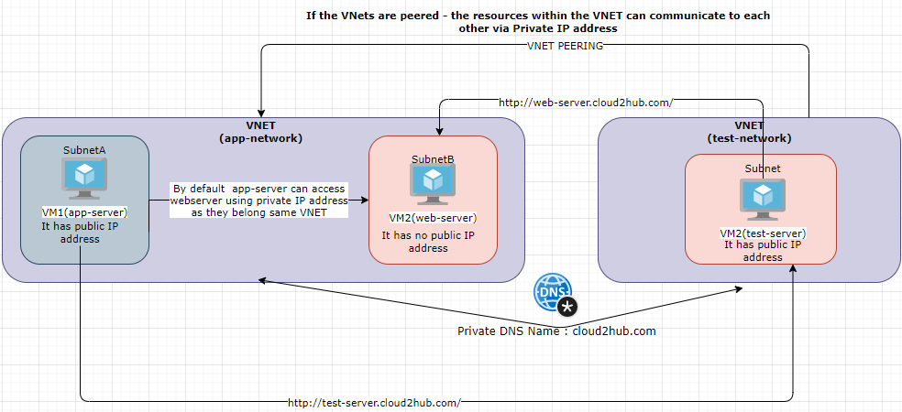

1. **CREATE A PRIVATE DNS ZONE IN ONE VIRTUAL NETWORK**
2. **ENABLE VIRTUAL NETWORK PEERING**: We need to establish a peering connection between the two virtual networks.
3. **ASSOCIATE THE PRIVATE DNS ZONE WITH THE VIRTUAL NETWORK**: In the Azure portal, navigate to the private DNS zone and associate it with the virtual network peering.

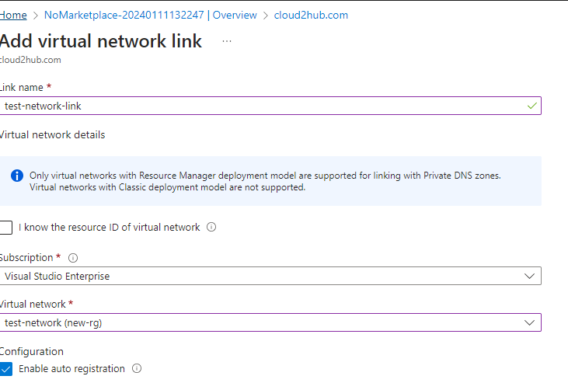

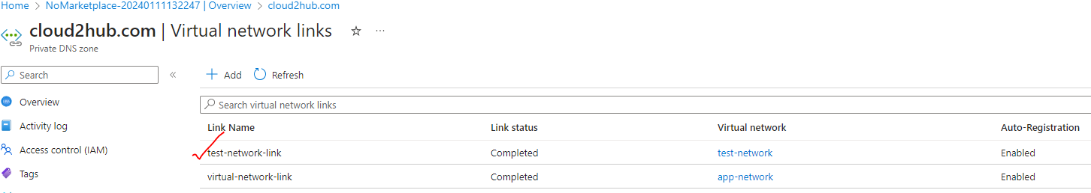

1. **CONFIGURE VIRTUAL NETWORK DNS SETTINGS**: Update the DNS settings of each virtual network to point to the private DNS zone. This ensures that the DNS resolution requests are sent to the private DNS zone for name resolution.

* Once the configuration is complete, you can resolve domain names across the peered virtual networks using the private DNS zone. This allows resources in different networks to communicate with each other using domain names, making it easier to manage and identify resources within your Azure environment.

**Accessing web-server from test-server**

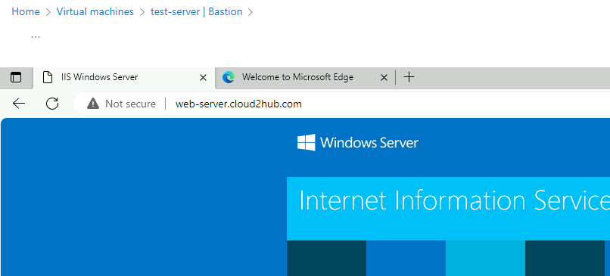

**Accessing test-server from app-server**

